**JAVASCRIPT**

1. **High level overview of JavaScript.**

JavaScript is a high-level, prototype-based, object-oriented, multi-paradigm, interpreted or just-in-time compiled, dynamic, single-threaded, garbage-collected programming language with first-class functions and a non-blocking event loop concurrency model.

* **high-level**: Every program that runs on your computer needs some hardware resources, such as memory and the CPU to do its work. Now, there are low-level languages, such as C where you have to manually manage these resources. For example, asking the computer for memory to create a new variable. On the other side, you have high-level languages such as JavaScript and Python where we do not have to manage resources at all because these languages have so-called abstractions that take all of that work away from us. This makes the language easier to learn and to use, but the downside is that programs will never be as fast or as optimized as for example, C programs.
* **garbage-collected**: Now, one of the powerful tools that takes memory management away from us developers is garbage-collection, which is basically an algorithm inside the JavaScript engine, which automatically removes old, unused objects from the computer memory in order not to clog it up with unnecessary stuff.
* **interpreted or just-in-time compiled language**: What you need to know for now is that the computer's processor only understands zeros and ones, that's right. Ultimately, every single program needs to be written in zeros and ones, which is also called machine code. We simply write human-readable JavaScript code, eventually needs to be translated to machine code. And that step can be either compiling or interpreting. In the case of JavaScript, this happens inside the JavaScript engine.
* **multi-paradigm language:** In programming, a paradigm is an approach and an overall mindset of structuring our code, which will ultimately direct the coding style and technique in a project that uses a certain paradigm. Now, three popular paradigms are-->procedural, object-oriented and functional programming. Also, we can classify paradigms as imperative or as declarative . Now, many languages are only procedural or only object-oriented or only functional, but JavaScript does all of it.

**first-class functions:** which simply means that functions are treated just as regular variables. So, we can pass functions into other functions and we can even return functions from functions. And this is extremely powerful because it allows us to use a lot of powerful techniques and also allows for functional-programming

* **dynamic language:** means dynamically-typed. So as we've already seen, in JavaScript, we don't assign data types to variables. Instead, they only became known when the JavaScript engine executes our code. Also, the type of variables can easily be changed as we reassign variables. If you think this is bad practice, if you yourself want to use JavaScript with types, then you can always look into TypeScript.
* **single-thread:** Single thread and the non-blocking event loop concurrency model. concurrency model is just a fancy term that means how the JavaScript engine handles multiple tasks happening at the same time. Well, because JavaScript itself runs in one single-thread, which means that it can only do one thing at a time

and therefore, we need a way of handling multiple things happening at the same time. Hence concurrency model. And by the way, in computing a thread is like a set of instructions that is executed in the computer's CPU. So basically, the thread is where our code is actually executed in a machine's processor. All right. But what if there is a long-running task, like fetching data from a remote server? Well, it sounds like that would block the single thread where the code is running, right? But of course, we don't want that. What we want is so-called non-blocking behaviour and how do we achieve that?

Well, by using a so-called event loop. The event loop takes long-running tasks, executes them in the background and then puts them back in the main thread once they are finished. And this is, in a nutshell, JavaScript's non-blocking event loop concurrency model with a single thread.

1. **JavaScript Engine and Runtime**

A JavaScript engine is simply a computer program that executes JavaScript code. Now every browser has its own JavaScript engine but probably the most well-known engine is Google's V-Eight. The V eight engine powers Google Chrome, but also Node.js which is that JavaScript runtime that we talked about in the beginning of the course, so the one that we can use to build server-side applications with JavaScript, so outside of any browser.

And of course, all the other browsers have their own JavaScript engines.

Any JavaScript engine always contains two components a call **stack** and a **heap**.

* The call stack is where our code is actually executed using something called **execution contexts**.
* Then the heap is an unstructured memory pool which stores all the objects that our application needs.

Alright, so with this look at the engine, we have answered where our code is executed. But now the question is how the code is compiled to machine code so that it actually can be executed afterwards?

Well, let's find out about the difference between compilation and interpretation.

we learned that the computer's processor only understands zeros and ones and that's therefore every single computer program ultimately needs to be converted into this machine code and this can happen using compilation or interpretation.

* So, in compilation, the entire source code is converted into machine code at once. And this machine code is then written into a portable file that can be executed on any computer. So, we have two different steps here. First, the machine code is built and then it is executed in the CPU so in the processor. And the execution can happen way after the compilation of course.
* Now, on the other hand in interpretation, there is an interpreter which runs through the source code and executes it line by line. So here we do not have the same two steps as before. Instead, the code is read and executed all at the same time. Of course, the source code still needs to be converted into machine code, but it simply happens right before it's executed and not ahead of time.

Now JavaScript used to be a purely interpreted language but the problem with interpreted languages is that they are much, much slower than compiled languages. This used to be okay for JavaScript, but now with modern JavaScript and fully fledged web applications that we built. Now many people still think that JavaScript is an interpreted language but that's not really true anymore. So instead of simple interpretation modern JavaScript engine now use a mix between compilation and interpretation which is called just-in-time compilation.

This approach basically compiles the entire code into machine code at once and then executes it right away. So, we still have the two steps of regular ahead of time compilation but there is no portable file to execute. And the execution happens immediately after a compilation. And this is perfect for JavaScript as it's really a lot faster than just executing code line by line.

So as a piece of JavaScript code enters the engine the first step is to parse the code which essentially means to read the code. During the parsing process, the code is parsed into a data structure called the abstract syntax tree or AST. This works by first splitting up each line of code into pieces that are meaningful to the language like the const or function keywords, and then saving all these pieces into the tree in a structured way. This step also checks if there are any syntax errors and the resulting tree will later be used to generate the machine code. If this tree has anything to do with the DOM tree and the answer is a very clear no. It's just a representation of our entire code inside the engine.

Anyway, the next step is compilation which takes the generated AST and compiles it into machine code. This machine code then gets executed right away because remember modern JavaScript engine use just-in-time compilation. And remember execution happens in the JavaScript engines call stack.

Modern JavaScript engines actually have some pretty clever optimization strategies. What they do is to create a very unoptimized version of machine code in the beginning just so that it can start executing as fast as possible. Then in the background, this code is being optimized and recompiled during the already running program execution. And this can be done most of the times and after each optimization the unoptimized code is simply swept for the new more optimized code without ever stopping execution of course.

And this process is what makes modern engines such as the V-Eight so fast and all this parsing, compilation and optimization happens in some special threads inside the engine that we cannot access from our code. So completely separate from the main thread that is basically running into call stack executing our own code.

We can imagine a **JavaScript runtime** as a big box or a big container which includes all the things that we need in order to use JavaScript in this case, in the browser. And to heart of any JavaScript, runtime is always a JavaScript engine. Without an engine there is no runtime and there is no JavaScript at all. However, the engine alone is not enough. In order to work properly, we also need access to the web APIs, so that's everything related to the DOM or timers or even the console.log that we use all the time. So essentially web APIs are functionalities provided to the engine, but which are actually not part of the JavaScript language itself. JavaScript simply gets access to these APIs through the global window object. But it still makes sense that the web APIs are also part of the runtime, because again a runtime is just like a box that contains all the JavaScript related stuff that we need.

Next a typical JavaScript runtime also includes a so-called **callback queue**. This is a data structure that contains all the callback functions that are ready to be executed. For example, we attach event handler functions to DOM elements like a button to react to certain events, right? And these event handler functions are also called callback functions okay. So as the event happens, for example a click, the callback function will be called.

And here is how that actually works behind the scenes.

So the first thing that actually happens after the event is that the callback function is put into the callback queue. Then when the stack is empty the callback function is passed to the stack so that it can be executed. And this happens by something called the event loop.

So basically, the event loop takes callback functions from the callback queue and puts them in the call stack so that they can be executed. And remember how I said in the last lecture that the event loop is how JavaScript's nonblocking concurrency model is implemented?

Well, here is an overview of how that works. Now we will go over why this makes JavaScript nonblocking in a special lecture about the event loop later in the course, because this is really a fundamental piece of JavaScript development that every developer needs to understand deeply.

Alright, so as they already said the focus in this course is on JavaScript in the browser and that's why we analysed the browser JavaScript runtime. However, it's also important to remember that JavaScript can exist outside of browsers,

for example, in Node.js.

And so here is what the node JS JavaScript runtime looks like. It's pretty similar, but since we don't have a browser of course, we can't have the web APIs because it's the browser who provides these. Instead, we have multiple C ++ bindings and a so-called thread pool. Now details don't matter here at all. I just want you to know that different JavaScript runtimes do exist..

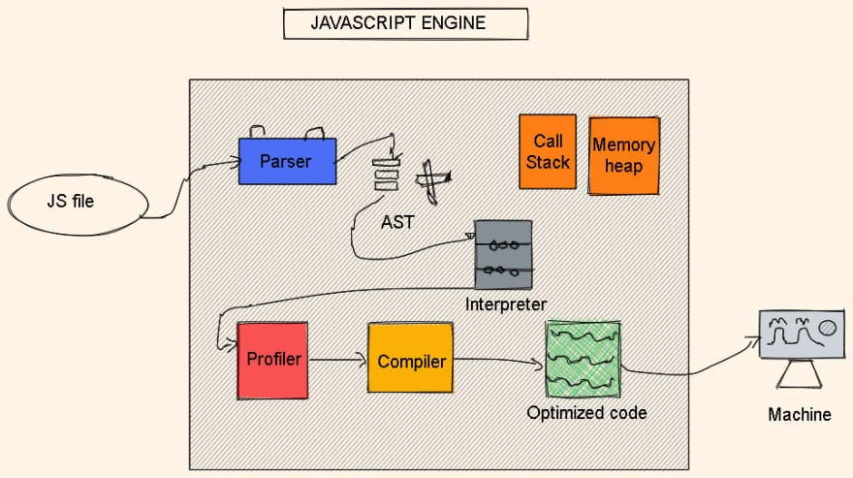

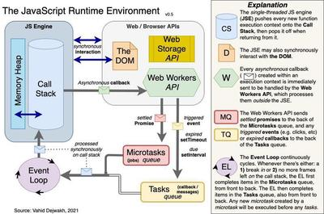

1. **Execution Context and Call stack**

How is JavaScript code executed?

We already know that it happens in a call stack in the engine, but let's dig a bit deeper now. And let's start by supposing that our code was just finished compiling. So the code is now ready to be executed. What happens then, is that a so-called global execution context is created for the top-level code. And top-level code is basically code that is not inside any function. So again, in the beginning only the code that is outside of functions will be executed. And this makes sense, right? Functions should only be executed when they are called.

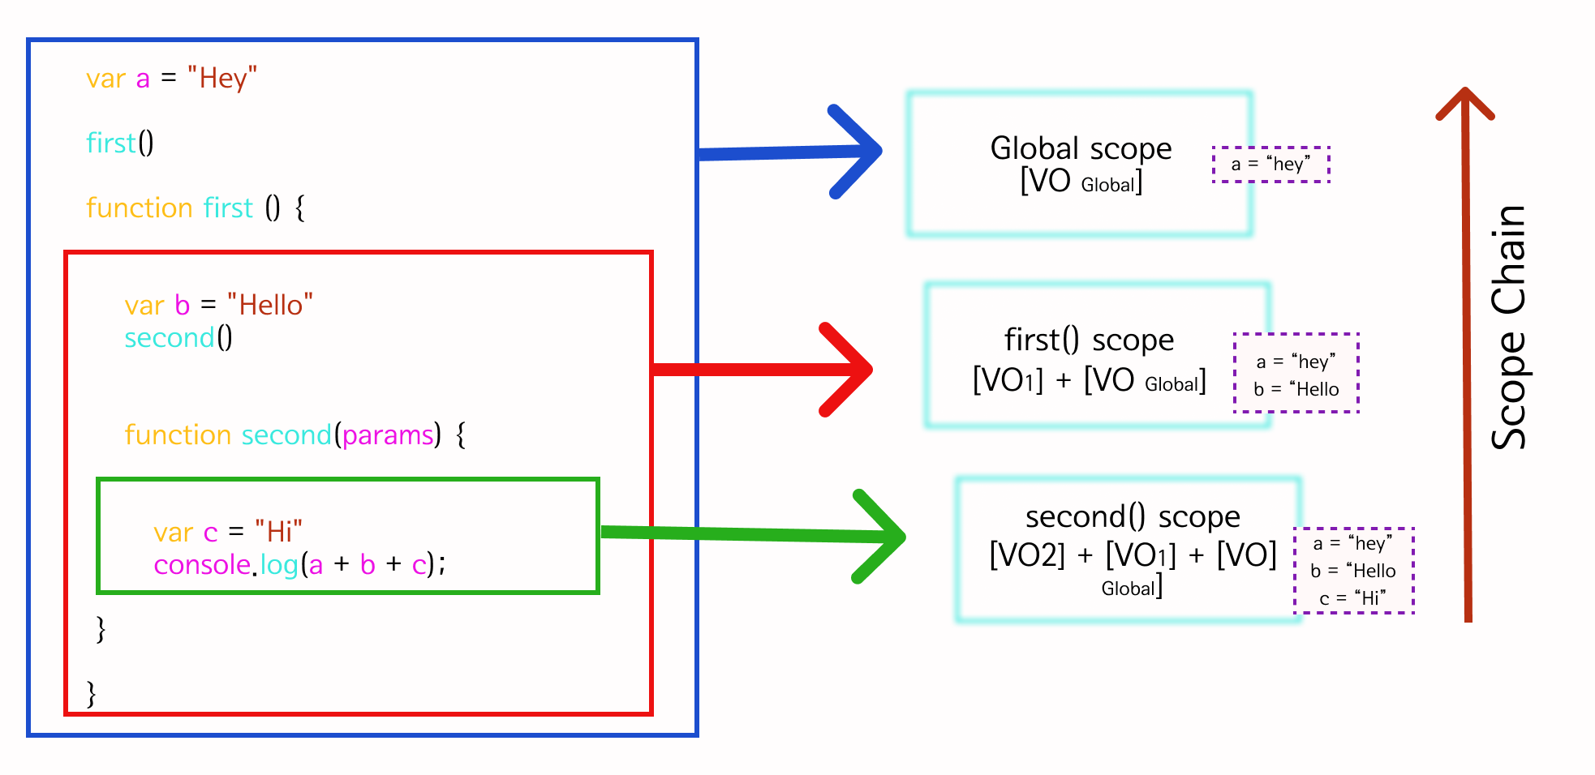

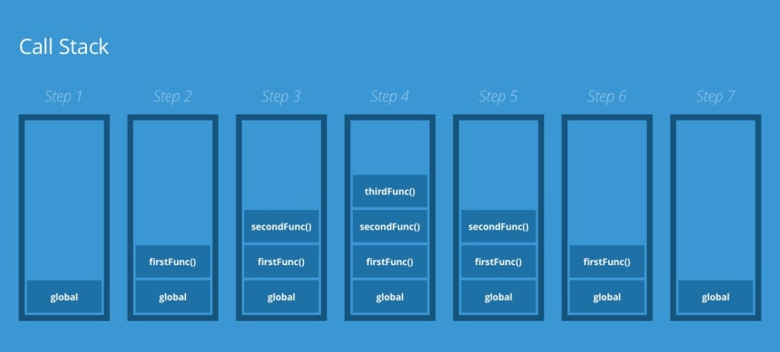

So this name variable declaration is clearly top-level code right?

And therefore, it will be executed in the global execution context. Next, we have two functions, one expression, and one declaration. So these will also be declared, so that they can be called later. But the code inside the functions, will only be executed when the functions are called. Okay, so we know that a global execution context is created for top-level code.

But now what exactly is an execution context?

Well, an execution context is an abstract concept. But I define it basically as an environment in which a piece of JavaScript is executed. It's like a box that stores all the necessary information for some code to be executed. Such as local variables or arguments passed into a function. So, JavaScript code always runs inside an execution context.

Now, in any JavaScript project, no matter how large it is, there is only ever one global execution context. It's always there as the default context, and it's where top-level code will execute.

And speaking of execute, now that we have an environment where the top-level code can be executed, it finally is executed. And there is not a lot to say about the execution itself. It’s just the computer CPU processing the machine code that it received.

*const* name = 'jonas';

*const* first = () => {

*let* a = 1;

*const* b = second();

    a = a + b;

    return a;

 }

*function* second() {

*var* c = 2;

    return c;

 }

*const* x = first()

Okay, and once this first code, so the top-level of code is finished, functions finally start to execute as well.

And here is how that works. For each and every function call, and you execution context will be created containing all the information that is necessary to run exactly that function.

And the same goes for methods, of course, because they're simply functions attached to objects remember?

Anyway, all these execution contexts together, make up the call stack that I mentioned before.

But more on that in a second. Now, when all functions are done executing, the engine will basically keep waiting for callback functions to arrive so that it can execute these.

For example, a callback function associated with a click event. And remember, that it's the event loop who provides these new callback functions as we learned in the last lecture.

All right. So we know now what an execution context is, but don't really know what it's made of. So, what's inside of it?

The first thing that's inside any execution context is a so-called variable environment. In this environment, all our variables and function declarations are stored, and there is also a special arguments object.

This object contains, as the name says all the arguments that were passed into the function that the current execution context belongs to.

Because remember each function gets its own execution context as soon as the function is called. So basically all the variables that are somehow declared inside a function, will end up in its variable environment. However, a function can also access variables outside of the function. And we have already seen that in action throughout this course, especially in the projects of the previous section. And this works because of something called the scope chain.

For now, what you need to know is that the scope chain basically consists of references to variables that are located outside of the current function.And to keep track of the scope chain, it is stored in each execution context.

Finally, each context also gets a special variable called the this keyword.

And once more, there is a special lecture just about the this keyword later in the section.

Okay.

Now, the content of the execution context, so variable environment, scope chain and this keyword is generated in a so-called creation phase Which happens right before execution.

And now just one final but very important detail that we need to keep in mind, is that execution contexts belonging to arrow functions, do not get their own arguments keyword, nor do they get the this keyword, okay? So, basically arrow functions don't have the arguments object and this keyword.

Instead, they can use the arguments object, and the this keyword from their closest regular function parent. And this is an extremely important detail to remember about arrow functions and we will come back to it later.

So these are the things that are necessary to run each function as well as the code in the top-level.

Now behind the scenes, it's actually even more complex but I think we're fine like this, aren't we?

And now let's actually try to simulate the creation phase for this code example here.

*const* name = 'jonas';

*const* first = () => {

*let* a = 1;

*const* b = second(7,9);

    a = a + b;

    return a;

 }

*function* second(*x*,*y*) {

*var* c = 2;

    return c;

 }

*const* x = first();

So, as you hopefully know, by now, we will get one global execution context and one for each function. So one for the first function, and one for the second function.

In the global context, we have the name variable declaration, the first and second function declarations, as well as the X variable declaration. For the functions, the variable environment will literally contain all the code of a particular function.

Now the value of X is marked as unknown here, because this value is the result of the first function that we didn't run yet. But we will simulate this in the next slide.

Now, technically none of these values actually become known during the creation phase, but only in the execution phase. So this is not 100% accurate here, but it's just to illustrate how these execution contexts work.

Okay? So just keep that in mind. Anyway, now in the first function, we have the a variable set to 1 and the b variable which once again requires a function call in order to become known.

Finally, the variable environment of the second function, contains the C variable set to 2, and since this is a irregular function, so not an arrow function, it also has the arguments object. And this object is an array, which contains all the arguments that were passed into the function when it was called. In this case, as you can see, that's 7 and 9.

Quite simple right?

Well, it's simple because this is an extremely small amount of code. But now imagine there are hundreds of execution contexts for hundreds of functions. How will the engine keep track of the order in which functions we're called? and how will it know where it currently is in the execution? Well, that's where the call stack finally comes in. And remember that the call stack, together with the memory heap, makes up the JavaScript engine itself.

But what actually is the call stack?

Well, it's basically a place where execution contexts get stacked on top of each other, in order to keep track of where we are in the programs execution. So the execution context that is on top of the stack, is the one that is currently running. And when it's finished running, it will be removed from the stack, and execution will go back to the previous execution context.

And so to demonstrate how the call stack works, let's walk through this code example together, so that I can show you exactly what happens. So, once the code is compiled, top-level code will start execution. And then as we learned in the beginning of the lecture, a global execution context will be created for the top-level of code, right? So this is where all the code outside of any function will be executed. And what happens with this execution context? Thats right, it will be put in the call stack. And since this context is now at the top of the stack, it is the one where the code is currently being executed. So, let's continue now with this execution. So here, there is a simple variable declaration. And then the first and the second functions are declared. So nothing fancy, but that's just how normal top-level code gets executed. But then, in the last line is where things start to get interesting.

Here, we declare the X variable, with the value that is going to be returned from calling the first function. And so let's actually call that function. Now what happens immediately when a function is called?

Well, it gets its own execution context so that it can run the code that's inside its body.

Perfect.

And what happens to the context?

Well, again it is put in the call stack, on top of the current context, and so it's now the new current execution context.

Great. So, let's continue. So we have yet another simple variable declaration here,and this variable will of course be defined in the variable environment of the current execution context,

and not in the global context, right? Then right in the next line, we have another function call.So, let's call that function and move there.And as you guessed a new execution context was created right away for this second function. And once more, it is pushed onto the call stack and becomes the new act of context.

Now what's important to note here is that the execution of the first function has now been paused, okay?

So again, we are running the second function now and in the meantime, no other function is being executed. The first function stopped at this point where the second function was called and will only continue as soon as this second function returns. And it has to work this way because remember,

JavaScript has only one thread of execution. And so it can only do one thing at a time.

Okay? Never forget that.

Now, moving to the next line, we have a return statement meaning that the function will finish its execution. So, what does that mean for the call stack? Well, it basically means that the function's execution context, will be popped off the stack and disappear from the computer's memory. At least that's what you need to know for now because, actually the popped off execution context might keep living in memory. But more about that later in the course. Anyway, what happens next, is that the previous execution context, will now be back to being the active execution context again. And so let's also go back to where we were before in the code.And I hope that by now,you start to see how the call stack really keeps track of the order of execution here.Without the call stack,how would the engine know which functionwas being executed before?

It wouldn't know where to go back to, right?

And that's the beauty of the call stack.It makes this process almost effortless.So I like to use the analogy of the call stack being like a map for the JavaScript engine.ecause the call stack ensures that the order of execution never gets lost.ust like a map does, at least if you use it correctly.

All right.

So, we returned from the second function, or back in the first function where we have this calculation,and then finally this first function also returns.

And so here the same as before happens. So the current execution context gets popped off the stack, and the previous context is now the current context where code is executed. In this case, we're back to the global execution context and the line of code where the first function was first called. So here, the return value is finally assigned to X and the execution is finished. Now the program will now actually stay in this state for forever until it is eventually really finished. And that only happens like when we close the browser tab, or the browser window. Only when the program is really finished like this, is when the global execution context is also popped off the stack. And this is in a nutshell how the call stack works. So hopefully it makes sense now that we say that Java script code runs inside the call stack. And actually it is more accurate to say that code runs inside of execution contexts that are in the stack. But the general point is that code runs in the call stack, which is of course true.

1. **Scopes and Scope Chain.**

Each execution context has a variable environment, a scope chain and a this keyword.

Scoping controls how our program's variables are organized and accessed by the JavaScript engine. So basically, scoping asks the question, where do variables live? Or where can we access a certain variable and where not?

* Now in JavaScript, we have something called lexical scoping and lexical scoping means that the way variables are organized and accessed is entirely controlled by the placement of functions and of blocks in the programs code. For example, a function that is written inside another function has access to the variables of the parent function.
* Variable scoping is influenced by where exactly we write our functions and code blocks.

**Scope:**

Scope is the space or environment in which a certain variable is declared.

In the case of functions, that’s essentially the variable environment which is stored in the functions execution context.

So if now you're asking yourself, what’s the difference between scope and variable environment? Then the answer is that for the case of functions, it’s basically the same.

**Scope of a variable**:

scope of a variable is basically the entire region of our code, where a certain variable can be accessed.

Now, some people use the word scope for all of this, but I like to define all these concepts that we have here in a clear way, because actually subtle differences.

For example, if you take a close look at it, scope is not the same as scope of a variable. And so you should know about the subtle differences, right?

The three different types of scope in JavaScript.

So that's **global scope, function scope and block scope.**

And remember, scope is the place in our code where variables are declared. And when I say variables, the exact same thing is true for functions as well. Because in the end, functions are just values that are stored in variables.

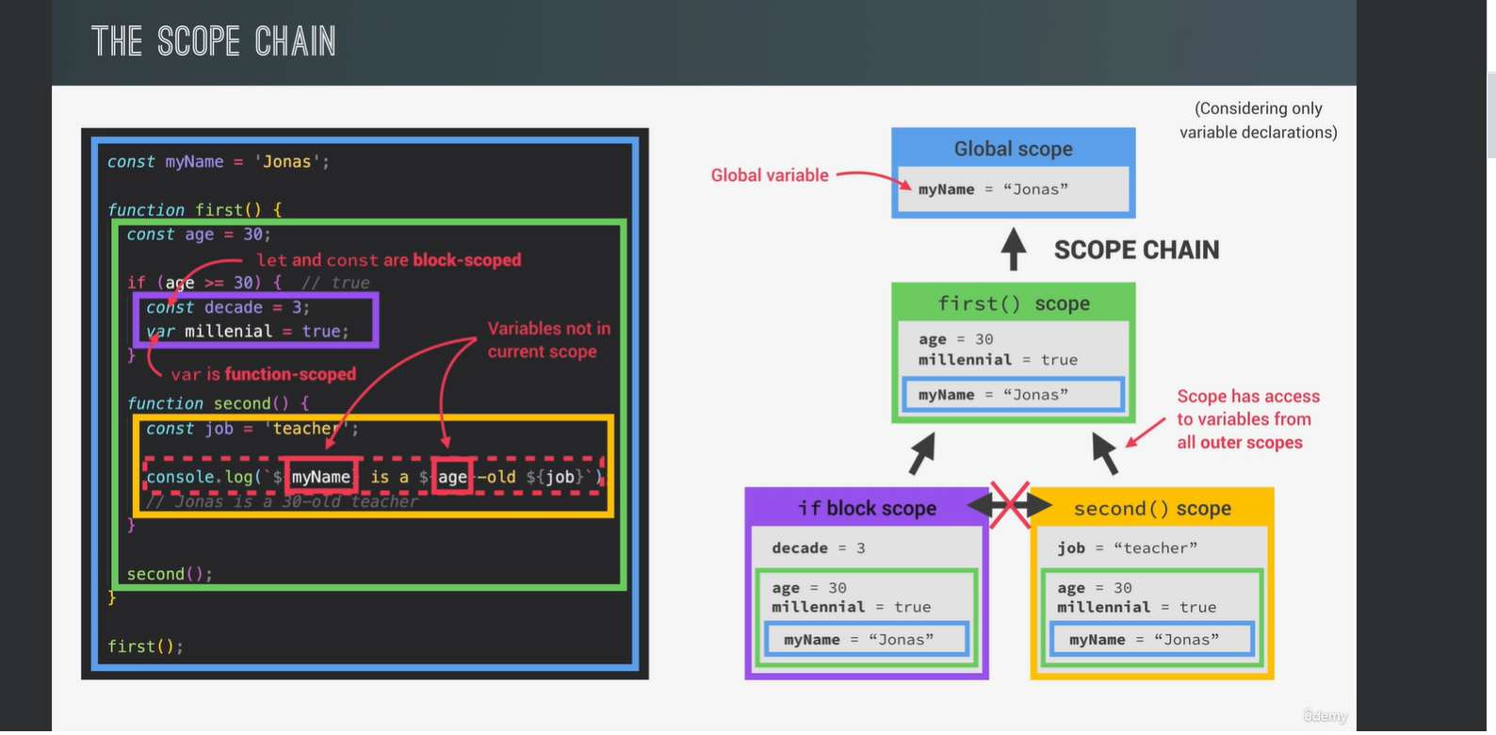

**Global scope:** is once more for top level code. So this is for variables that are declared outside of any function or block. These variables will be accessible everywhere in our program, in all functions and all blocks. So really, everywhere.

**Function scope:** each and every function creates a scope. And the variables declared inside that function scope are only accessible inside that function. This is also called a local scope opposed to the global scope. So local variables live in the function so to say. And outside of the function, the variables are then not accessible at all.

Again, this is technically the same as the function’s variable environment, but we still need to give it the name of scope in this context, because blocks also creates scopes.

Anyway, in this example here,

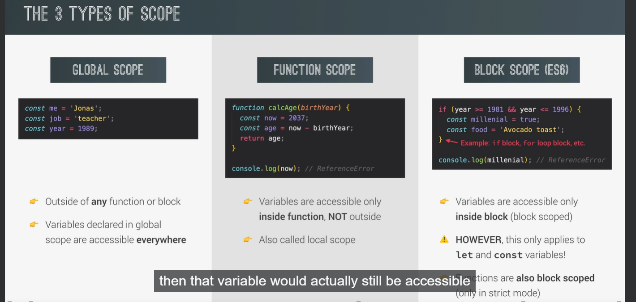

the now variable is 2037 inside the calcAge function. And therefore, we can use it in the function to do calculations. But outside of the function, as we try to log it to the console, we get a reference error. So JavaScript is trying to find the now variable in this global scope, so outside of the function, but it cannot find it. And so there is going to be an error.

And here, it actually does not matter what kind of function we're using. So, function declarations, function expressions and arrow functions all create their own scope.

**Block scope:**

Now traditionally, only functions used to create scopes in JavaScript. But starting in ES6, blocks also creates scopes now. And with blocks, we mean everything that is between curly braces, such as the block of an if statement or a for loop. So just like with functions, variables declared inside a block are only accessible inside that block and not outside of it.

Now, the big difference is that block scopes only apply to variables declared with let or const, okay?

So again, only let and const variables are restricted to the block in which they were created.

That's why we say that let and const variables are block scoped. So if I declared a variable using var in this block, then that variable would actually still be accessible outside of the block, and would be scoped to the current function or to the global scope.And so we say that var is function scoped. So in ES5 and before, we only had global scope and function scope. And that's why ES5 variables declared with Var, only care about functions, but not about blocks. They simply ignore them. Finally, also starting in ES6,all functions are now also block scoped, at least in strict mode, which you should always be using anyway.

And just like with let and const variables, this means that functions declared inside a block are only accessible inside that block, okay?

And of course, we start with the global scope.

As you can see, the myName variable is the only variable declaration that we have in the global scope.

Now, technically, the first function also counts as a variable that is present in the global scope,but I want to keep it simple here. And so I will only consider variable declarations and no functions, all right?

Just keep in mind that whatever I'm explaining here for variables also works the same for functions.Anyway, inside the global scope,we have a scope for the first function because each function creates its own scope, remember?And what's in the scope?

Well, it's to age variable that's declared right at the top of the function. Next inside the first scope,let's now consider the second function,which will also create its own scope containing the job variable set to teacher.

So as you see,we have a nested structure of scopes with one scope inside the other.But now comes the actually interesting part.

Because here in the second function,we have this line of code where we need the myName variable and the age variable,which were both not declared inside the current scope. But we really need these variables here,because otherwise we can't create this string here, right? So how can this be fixed? How will the JavaScript engine know the values of these variables? Well, the secret is that every scope always has access to all the variables from all its outer scopes. So from all its parent scopes.In our example, this means that the second scope can access the age variable from the scope of the first function. Of course, this also means that the first scope can access variables that are in the global scope, because that is the parent scope. As a consequence of this,the second scope will then also be able to access the myName variable from the global scope, because it has access to the variables from the first scope. And by the way, all this also applies to function arguments. But in this example, we just don't have any. And this is essentially how the scope chain works. In other words, if one scope needs to use a certain variable, but cannot find it in the current scope, it will look up in the scope chain and see if it can find a variable in one of the parent scopes. If it can, it will then use that variable. And if it can't, then there will be an error. And this process is called variable lookup. Now it's important to note that these variables are not copied from one scope to another, okay? Instead, scopes simply look up in the scope chain until they find a variable that they need and then they use it. What's also extremely important to note is that this does not work the other way around. A certain scope will never, ever have access to the variables of an inner scope. In this example, the first scope, for example, will never get access to the job variable that is stored in the second scope, okay? So again, one scope can only look up in a scope chain, but it cannot look down basically. So only parent scope can be used, but no child scopes. Anyway, with all this in place now, this line of code can be executed and print to the console. Jonas is a 30 year old teacher, even though the myName and age variables were not defined in the current scope. All the engine did was to get them from the scope chain. And as you might be noticing, we have actually already done this before in our own code. We just didn't really understand what was going on and how it all worked. But now we do know how it works. Amazing, right? Anyway, we still have one more scope left here, and that's the one created by this block here. Remember that starting with ES6, not only functions create scopes, but also blocks. However, these scopes only work for the ES6 variable types. So for let and const variables. That's why the only variable that's in the scope is the decade variable. The millennial variable isn't declared with const or let, and therefore it is not scoped to just this block. Instead, the millennial variable is actually part of the first function scope. So again, for a variable declared with var, block scopes don't apply at all. They are functions scoped, not block scoped. Let and const on the other hand are in fact blocks scoped, okay? This is one of the fundamental things that you need to keep in mind about let, const and var, and about scoping in general. So if you're taking notes and I hope you are taking lots of notes, then this must definitely be in there. Now about a scope chain, if the millennial variable is in the first function scope, then of course the second function scope also has access to it, even if it doesn't really need that variable. Also the scope chain does of course, apply to block scopes as well. And therefore in or if block scope, we get access to all the variables from all its outer scopes. So from the first function scope, and of course from the global scope. That's why I said in the last slide that variables in a global scope are accessible from everywhere. They are, because they are always at the top of the scope chain. In fact, we call variables in the global scope, global variables, very creative, right? But we actually use this term a lot in JavaScript. Now it's important to understand that our purple blocks scope does not get access to any variables from the yellow second function scope. And the same, the other way around. And why is that? Well it's because of lexical scoping as we learned in the last slide. So the way that we can access variables depends on where the scope is placed, so where it is written in the code. In this case, none of these two scopes is written inside of one another. They're both child scopes of the first function. We could even say that they are a sibling scopes. And so by the rules of lexical scoping, they cannot have access to each others variables, simply because one is not written inside the other one. We can also say that the scope chain only works upwards, not sideways. Okay, so this was a lot to take in, but I hope that everything's still keeps making sense at this point. And if not, don't worry, we will see all this working in practice in the next video. But for now, though, there is one more thing that we need to talk about, which is the difference between the scope chain and to call stack. I get a lot of questions about this all the time. And so I decided to talk about how the call stack, execution context, variable environments and scope are all related to one another. So before we move on to the next video. And once more, let's look at some more code here. So we have three functions called first, second and third, in order to make this easier to understand. We start by calling the first function, which then calls the second function, which in turn calls the third function. So from what we learned before, the call stack for this example will look like this, right? One execution context for each function in the exact order in which they were called. They also included the variable environment of each execution context. For now, all this has nothing to do with scopes or the scope chain, all right? All I'm doing is creating one execution context for each function call and filling it with the variables of that function. And you can pause the video here for a moment to understand the content of each variable environment. Okay, and now that you did that and we have all these variable environments in place, we can actually start building the scope chain. As always, we're gonna start with the global scope. And the variables available in the global scope are exactly the ones stored in the variable environment of the global execution context. And given everything we've learned so far, that makes sense, right? And note that in this example, I am actually including functions in each scope unlike we did in the previous slide. Now in the global scope, we also call the first function, which is the reason why we have an execution context for it in the call stack. And this function of course, also gets its own scope, which contains all the variables that are declared inside of the function. And once again, this is exactly the same as the variable environment of the functions execution context. However, that's not all because now we already know about the scope chain. So the first scope also gets access to all the variables from its parent scope, thanks to the scope chain. Now, as we already know, the scope chain is all about the order in which functions are written in the code. But what's really important to note here is that the scope chain has nothing to do with the order in which functions were called. Or in other words, the scope chain has nothing to do with the order of the execution contexts in the call stack. The scope chain does get the variable environments from the execution context as shown by the red arrows here, but that's it. The order of function calls is not relevant to the scope chain at all, all right? Really keep that in mind. Now, moving on to the second function now, once again, its scope is equal to its variable environment. Also it's lexically written within the first function. And so of course, it will have access to all its parent scopes as well. So we can say that the scope chain in a certain scope is equal to adding together all the variable environments of all the parent scopes. And so this is our scope, and the scope chain are built in the JavaScript engine behind the scenes. Okay. Now in the second function, we try to call the third function. But why does that work? Well, it works because the third function is in the scope chain of the second function scope as we can see here in our scope chain diagram. It's a function in the global scope or a global function, and therefore it's accessible everywhere. Of course, this will create a new scope along with the scope chain as we already know. Great, so what happens in this third function? Well, we're trying to act as variables B, C, D and A here. D is no problem because it's right there in the third function scope. So that one is easy. Then variable C is not in a local scope and so JavaScript needs to do a variable lookup. So it looks up in a scope chain looking for variable C, but it's not there. And of course it isn't, because C is defined in the second function, and there is just no way in which the third function can access variables defined in the second function. And that is true, even though it was the second function who called the third. And so here is even more proof that the order in which functions are called does not affect the scope chain at all. And so here as a result, we get the reference error because both C and B cannot be found in the third scope nor in the scope chain. Okay. And with this, I hope I made it crystal clear that execution context, variable environments, the call stack scope and the scope chain are all different, but still very related concepts. And if it's not yet crystal clear, then it's no problem to maybe rewatch this slide, or maybe even this entire lecture a little bit later. And I know that this was quite a long lecture with a ton of stuff to take in. And so here is a handy summary with the main takeaways from this video. So to start, scoping asks the question, "Where do variables live?" Or "Where can we access a certain variable, "and where not?" That's what scoping is all about. Now, there are three types scope in JavaScript. The global scope, scopes defined by functions and scopes defined by blocks, starting in ES6. However, only let and const variables are block scoped. Variables declared with var automatically end up in the closest function scope. Next in JavaScript, we have lexical scoping, which means that the rules of where we can access variables are based on where in the code functions and blocks are written. And now, let the magic begin, because every scope always has access to all the variables from all it's outer scopes. And this is what we call the scope chain. When a certain variable is not in the current scope, the engine looks up in the scope chain until it finds the variable that it's looking for, and this process is called variable lookup. It's important to note that the scope chain is a one way street. So a scope will never ever have access to the variables of an inner scope, only of outer scopes. We can also think of the scope chain in a certain scope as being equal to adding together all the variable environments of all the parent scopes. And finally, we need to keep in mind that the scope chain has nothing to do with the order in which functions were called. So the order of function calls does not affect the scope chain at all. Okay, and now that's actually it. This is in a nutshell, scoping in JavaScript. See you in the next video.

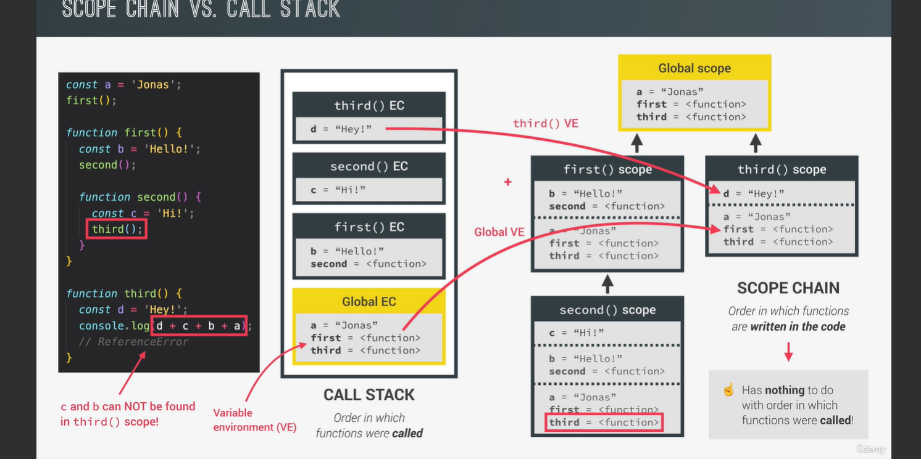

Output of below code :

Jonas you are 46, born in 1991;Oh you are millennial , steven

True; New output!

*///////////////////////////////////////*

*// Scoping in Practice*

*function* calcAge(*birthYear*) {

*const* age = 2037 - birthYear;

*function* printAge() {

*let* output = `${firstName}, you are ${age}, born in ${birthYear}`;

    console.log(output);

    if (birthYear >= 1981 && birthYear <= 1996) {

*var* millenial = true;

*// Creating NEW variable with same name as outer scope's variable*

*const* firstName = 'Steven';

*// Reasssigning outer scope's variable*

      output = 'NEW OUTPUT!';

*const* str = `Oh, and you're a millenial, ${firstName}`;

      console.log(str);

*function* add(*a*, *b*) {

        return a + b;

      }

    }

*// console.log(str);*

    console.log(millenial);

*// console.log(add(2, 3));*

    console.log(output);

  }

  printAge();

  return age;

}

*const* firstName = 'Jonas';

calcAge(1991);

*// console.log(age);*

*// printAge();*

.

1. **Variable Environment: Hoisting and TDZ**

We learned that an execution context always contains three parts: A variable environment, the scope chain in the current context and the this keyword.

It's time to take a closer look at the variable environment and in particular at how variables are actually created in JavaScript.

So, in JavaScript we have a mechanism called **hoisting** and hoisting basically make some types of variables accessible or let's say usable in the code before they are actually declared in the code.

Now, many people simply define hoisting by saying that variables are magically lifted or moved to the top of their scope. for example, to the top of a function and that is actually what hoisting looks like on the surface.

But behind the scenes that's in fact not what happens. Instead, behind the scenes the code is basically scanned for variable declarations before it is executed. So, this happens during the so-called creation phase of the execution context. Then for each variable that is found in the code, a new property is created in a variable environment object.And that's how hoisting really works.

Now, hoisting does not work the same for all variable types. So, let's analyse the way hosting works for function declarations, variables defined with var, variables defined with let or const and function expressions and also arrow functions.

**Function declarations:** are actually hoisted and the initial value in the variable environment is set to the actual function. So in practice, what this means is that we can use function declarations before they are actually declared in the code, again, because they are stored in the variable environment object, even before the code starts executing. It is because of hoisting.

Function declarations are block scoped as we learned before. Just keep in mind that this is only true for strict mode. So if you're using a sloppy mode, which you shouldn't ,then functions are functioned scoped.

Next, **variables declared with var** **are also hoisted**, but hoisting works in a different way here.So unlike functions,when we try to access a var variable before it's declared in a code,we don't get the declared value but we get undefined.And this is a really weird behavior for beginners.You might expect that you simply get an error when using a variable before declaring it or to get the actual value.But not to get undefined because getting undefined is just really weird and it's not really useful either, right?And actually this behavior is a common source of bugs in JavaScript.So this is one of the main reasons why in modern JavaScript we almost never use var.

Now on the other hand, **let and const variables** **are not hoisted**.I mean, technically they are actually hoisted but their value is basically set to an initialized.So there is no value to work with at all.And so in practice, it is as if hoisting was not happening at all.Instead, we say that these variables are placed in a so-called Temporal Dead Zone or TDZ which makes it so that we can't access the variables between the beginning of the scope and to place where the variables are declared.So as a consequence,if we attempt to use a let or const variable before it's declared, we get an error.Also keep in mind that let and const are block scoped.So they exist only in the block in which they were created.And all these factors together is basically the reason why let and const were first introduced into the language,and why we use them now instead of var in modern JavaScript.

But now what about **function expressions and arrow functions?** How does hoisting work for this?

Well, it depends if they were created using var or const or let. Because keep in mind that these functions are simply variables. And so they behave the exact same way as variables in regard to hoisting.This means that a function expression or arrow function created with var is hoisted to undefined. But if created with let or const,it's not usable before it's declared in a code because of the Temporal Dead Zone so again, just like normal variables, right?And this is actually the reason why I told you earlier that we cannot use function expressions before we write them in the code,unlike function declarations.

But now before finishing,let's take a more detailed look at this mysterious Temporal Dead Zone.

So in this example code we're gonna look at the job variable.

It is a const so it's scoped only to this if block and it's gonna be accessible starting from the line where it's defined.

Why?

Well, because there is this Temporal Dead Zone for the job variable.It's basically the region of the scope in which the variable is defined,but can't be used in any way.

So it is as if the variable didn't even exist.Now, if we still tried to access the variable while in the TDZ like we actually do in the first line of this if block,then we get a reference error

telling us that we can't access job before initialization. So exactly as we learned in the last slide, right?

However, if we tried to access a variable that was actually never even created,like in the last line here

where we want to log x,then we get a different error message

const myName = 'jonas';

if(myName === 'jonas'){

conole.log('jonas is a $[job}');

const age = 2037 -1989;

console.log(age);

const job = 'teacher';

console.log(x);

}

saying that x is not defined at all.What this means is that job isin fact in the Temporal Dead Zone where it is still initialized,but the engine knows that it will eventually be initialized because it already read the code before and set the job variable in the variable environment to uninitialized.

Then when the execution reaches the line where the variable is declared,it is removed from the Temporal Dead Zone

and it's then safe to use.So to recap, basically each and every let and const variable get their own Temporal Dead Zone that starts

at the beginning of the scope until the line where it is defined.And the variable is only safe to use after the TDZ,so the Temporal Dead Zone.

Alright, now what is actually the need for JavaScript to have a Temporal Dead Zone?

Well, the main reason that the TDZ was introduced in ES6 is that the behavior I described before makes it way easier to avoid and catch errors.

Because using a variable that is set to undefined before it's actually declared can cause serious bugs which might be hard to find.

And I will show you a small example in the next lecture. So accessing variables before declaration is bad practice and should be avoided.

And the best way to avoid it is by simply getting an error when we attempt to do so. And that's exactly what a Temporal Dead Zone does.A second and smaller reason why the TDZ exists

is to make const variables actually work the way they are supposed to.

So as you know, we can't reassign const variables.So it will not be possible to set them to undefined first

and then assign their real value later.Const should never be reassigned.And so it's only assigned when execution

actually reaches the declaration.And that makes it impossible to use the variable before.

Okay? Makes sense?

Now, if hoisting creates so many problems,why does it exist in the first place?

I get this question all the time.And so let's quickly talk about that here.So the creator of JavaScript basically implemented hoisting so that we can use function declarations before we use them.

Because this is essential for some programming techniques,such as mutual recursion.Some people also think that it makes code a lot more readable.Now, the fact that it also works for var declarations

is because that was the only way hoisting could be implemented at the time.So the hoisting of var variables is basically just a byproduct of hoisting functions.

And it probably seemed like a good idea to simply set variables to undefined,which in hindsight is not really that great.But we need to remember that JavaScript was never intended to become the huge programming language that it is today.

Also, we can't remove this feature from the language now.And so we just use let and const to work around this

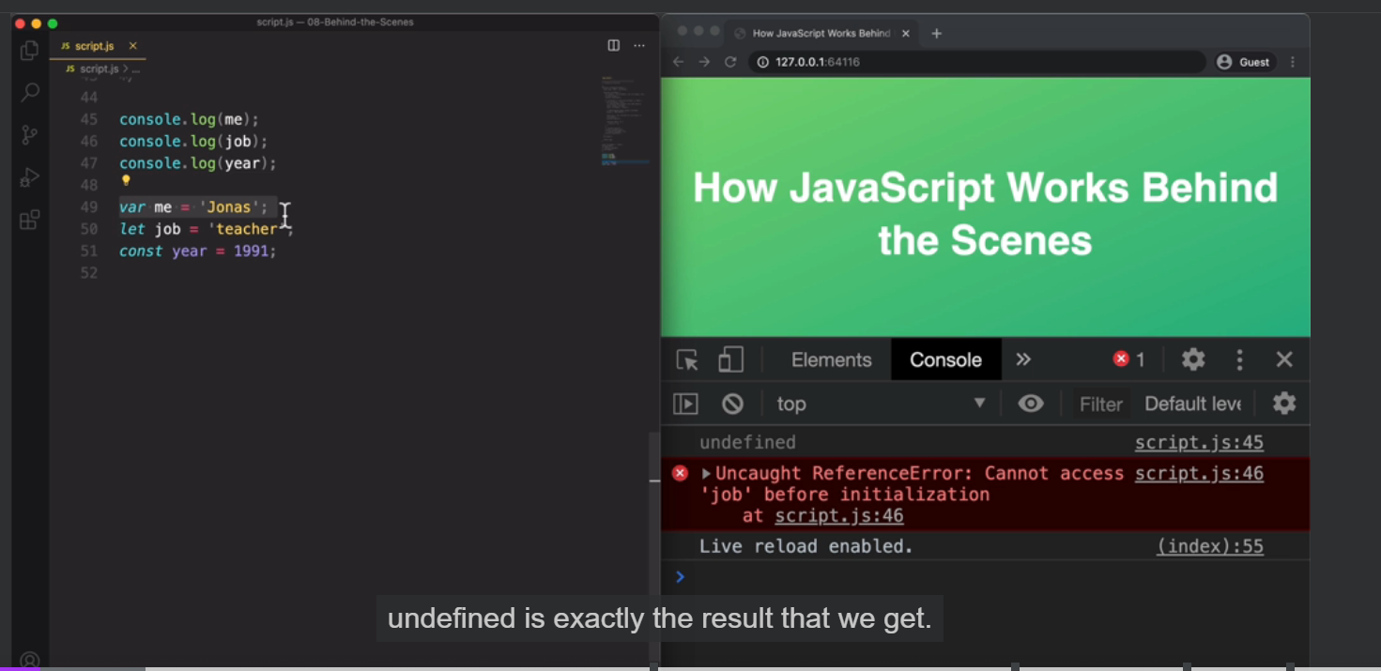

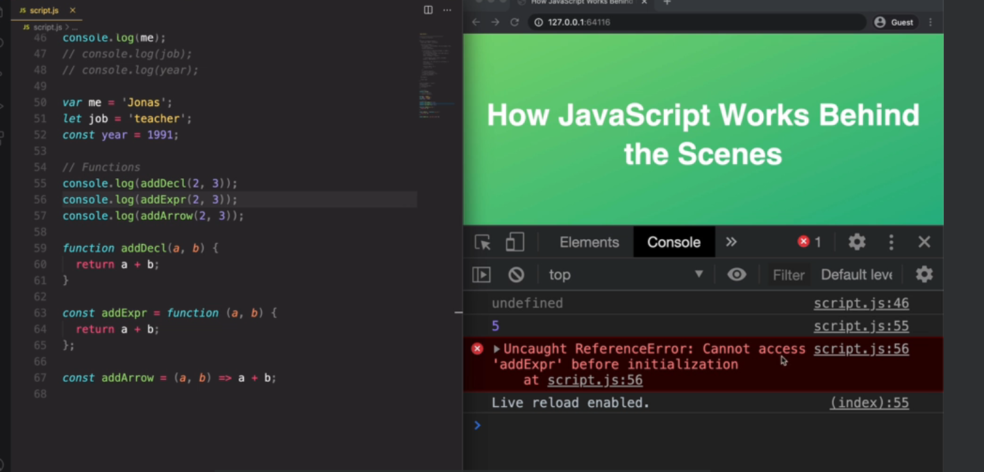

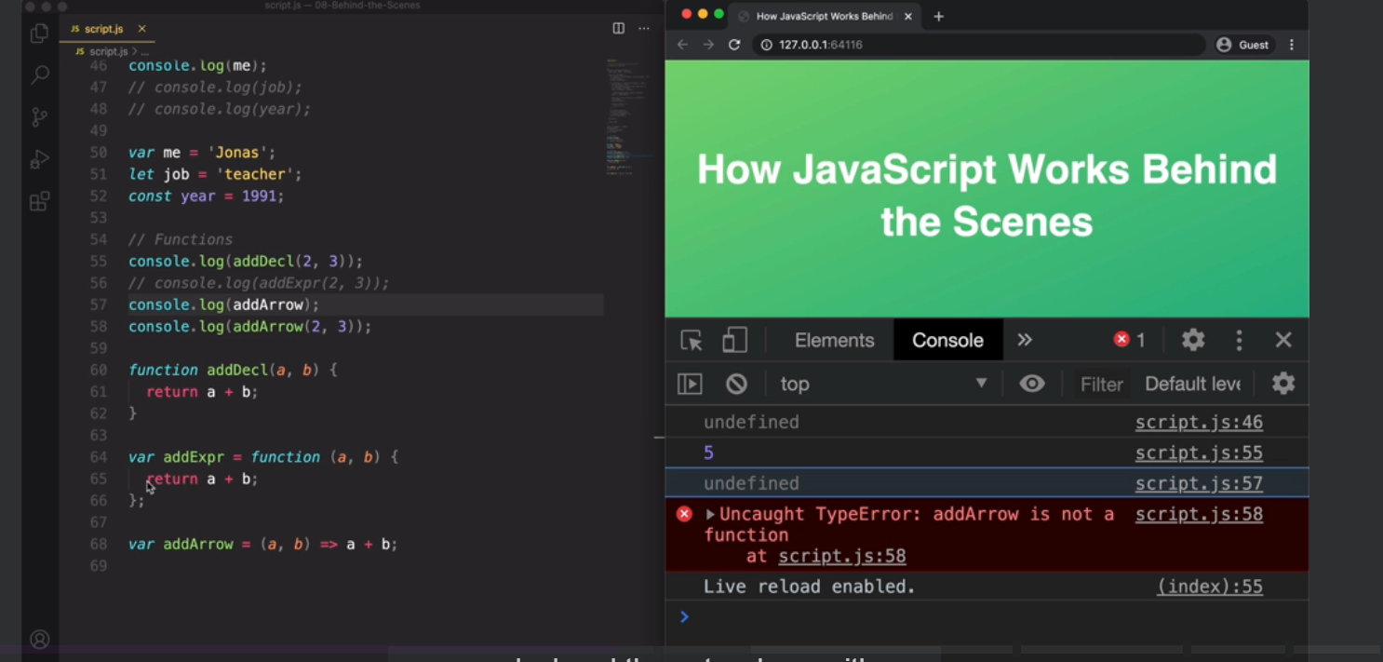

Pitfall of using var:

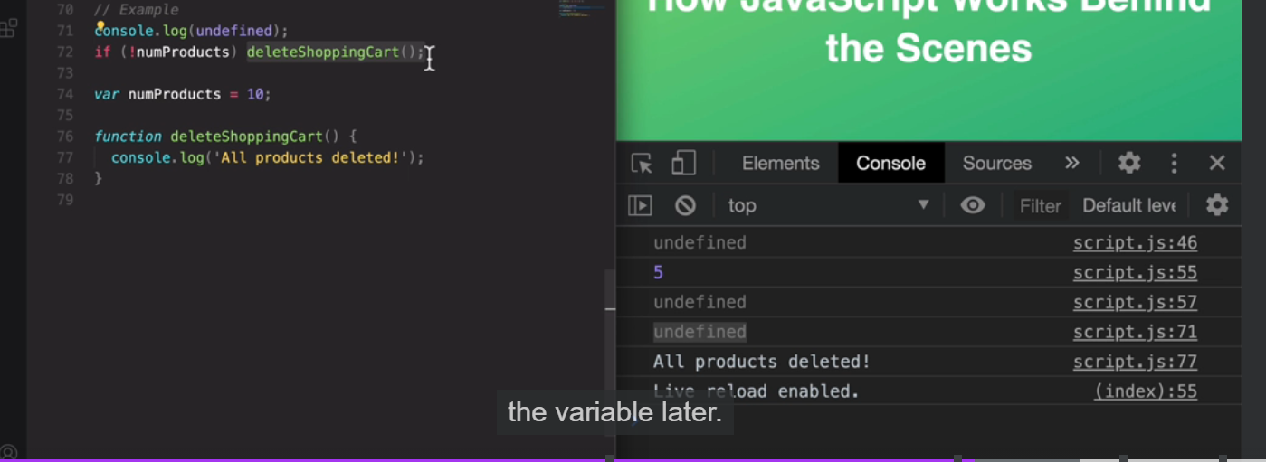

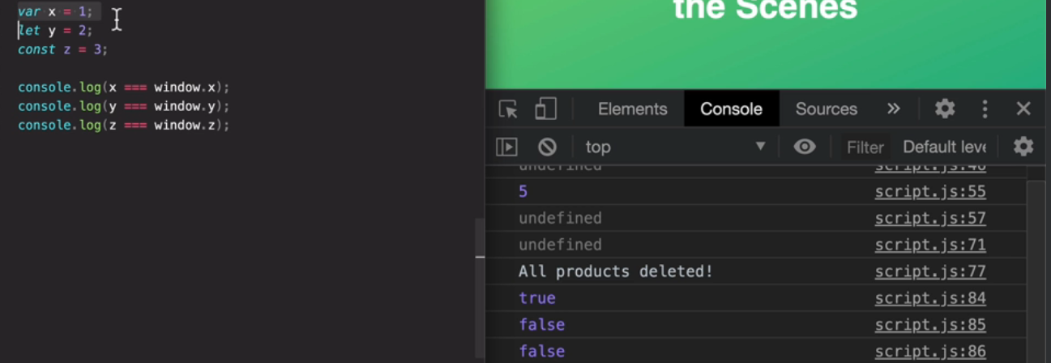

1. **This Keyword**

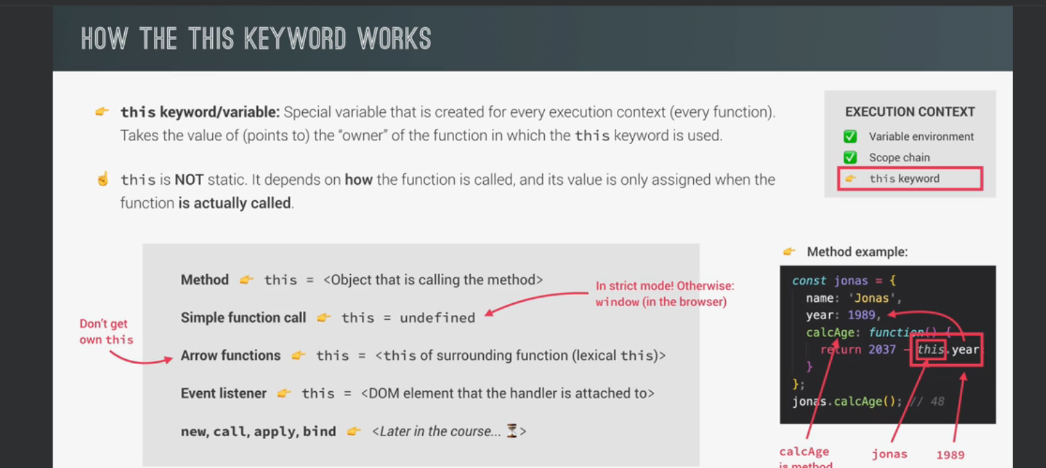

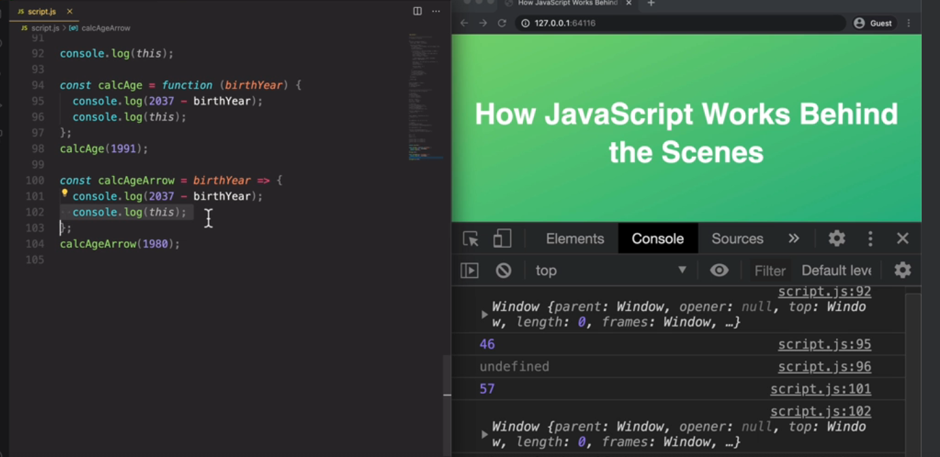

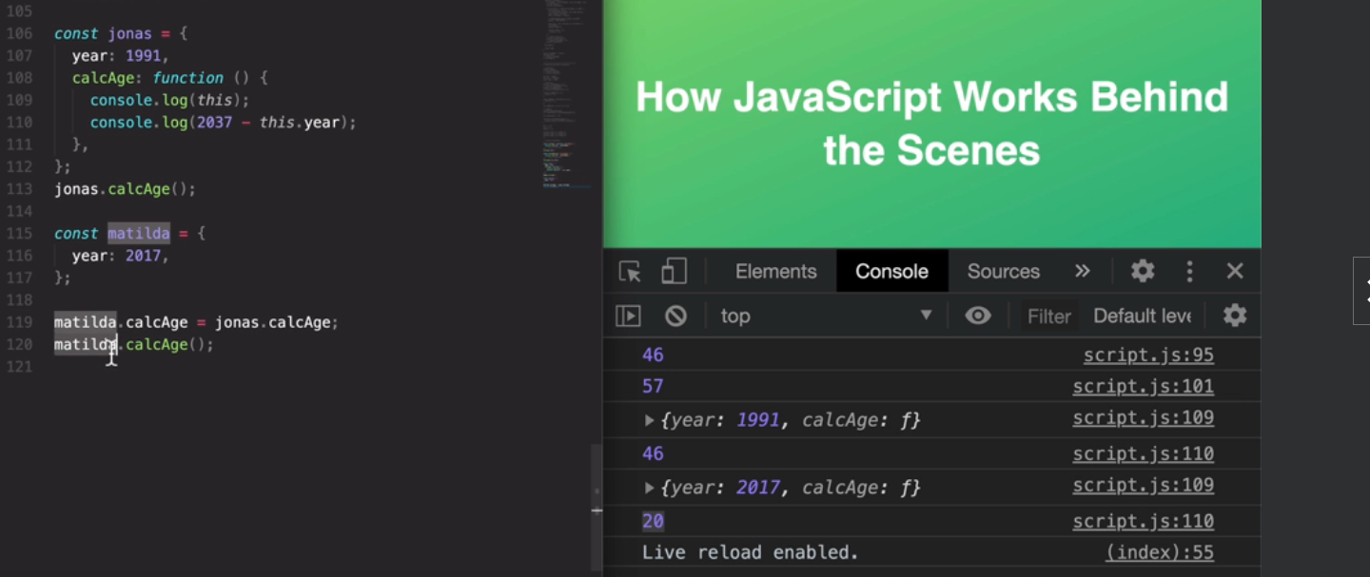

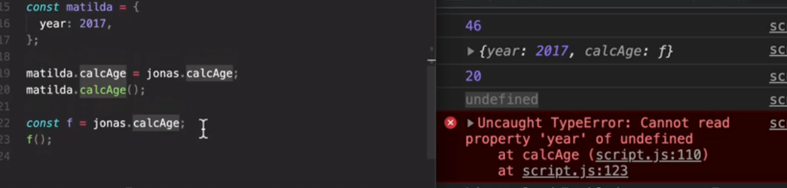

let's start by taking a look at the this keywords outside of any function whatsoever. So just outside here in the global scope.

And so we get that the this keyword in the global scope is simply the window object. So that's the global object that we just saw before.

Remember, and now let's do the same but inside of just a regular function call so we're going to use or old friend calAge() here.

So let's look to the console, just the usual result so that we're actually doing something here.

But then what we're really interested in is taking a look at this, this keyword. So let's now call this function.

And so let's see. And now the result of taking a look so at the logging, the this keyword is undefined. Okay.

And so what that means is that insight is just regular function. Call here.

The this keyword will be undefined and that's because we are in strict mode. Remember that in sloppy mode, it would be also the global object.

So in this case, the window object but you already know that you always should use strict mode.

And so then in a regular function call like this D this keyboard will simply point to undefined and with a regular function call

I simply mean a call of disfunction without the function being attached to any object.

So without having an owner so to say, but now let's see what happens. If this function here was an arrow function.

So let's just copy this. So cog H both here and here arrow, and let's call this one with a different value.

And now think about the rules that we learned in the last video.

So what do you think the this keyword will be if dysfunction is an arrow function and actually we still need to do that.

So birth year. And so now it is a legit arrow function. And so once more, what do you think that these keywords will now be think hard about it?

And then let's check and so it is window. So that's a little bit weird maybe right? So why is that?

Why is the disk keyword undefined in this function, but window in this function?

Well, it is because the arrow function does not get its own this keyword. So instead the arrow function simply uses the lexical this keyword,

which means that it uses the this keyword of its parent function or of its parents scope.

So to say and in this case, what is the lexical, this keyword? So what is the this keywords in the parent's scope of this function?

Well, it is window because window is the this keywords here in the global scope. So right here. Okay. That's why I started by showing you this one here. So in this case, this, this keyword here will simply point to the this keyword in the global scope. And so therefore it will point to window and like here in this normal function which does actually get it's own this keywords it's simply as undefined here but it is its own this keyword while this one here in the arrow function is actually not the this keywords of this function here. Okay.

It is simply the this keyword of the parent's scope. And that happens to be the window object. In this case, in the next video we will see some more real world implications of the fact that the arrow function does not get its own this keyword. Now, next up let's try to use the this keyword inside of a method.

So let's quickly create a Jonas object here just with a birth year, 1991, and then again, or caulk H method. And so remember that this is basically now a function expression that we need to write here. Now let's lock the this keyword here and then let's call actually the caulk H function for now, just to see what the, this keyword will look like. And my hope is that you can guess already what it should look like. So let's save it to see the result. And indeed it is T Jonah's object. So exactly this object with caulk age and year. And so it means that's exactly this object. And that's exactly the rule that I told you in the previous lecture. So when we have a method call, the this keyword insight of the method will be the object that is calling the method.

And in this case, that's the Jonas object. So Jonas here is basically the owner of the method. That's another way of saying it and therefore, insight of cog H this is Jonas. And then we can use that to our advantage, to calculate the age here based on the data that is already in this object. And so that's one of the big use cases for the this keyword, right?

Because then we don't have to pass in this data here again. So instead of having to do this again we can simply use the birth year that is already in the object itself. And so we can use the this award to reference that object. And so this should now give us, or a usual value here of 46. Great. So that's pretty important stuff.

And now let's move on just to one final example here in this lecture. So I keep saying that the this keyword will point to the object that is calling the method, right? And that means that the this keyword will not simply point at the object in which we wrote the method. So here we wrote the caulk H method inside of the Jonas object. And so we might think that debt is the reason why the this keyword points to Jonas, but that is not true. The reason that the this keyword will point to Jonas in this case is because Jonah's was the object calling debt method and that's a subtle, but very important difference.

And let me know, show you why that is. So let's create a new object which I'm going to call a Matilda and let's create a first name. We're actually, we don't need a name. Let's just say, year 2017. And that's it. That's all we need in this object. Now, remember that a function is just a value right? And therefore we can do this. We can say Matilda thought caulk eight should be equal to Jonas that caulk H so basically here we simply copy the caulk H method from Jonah's to Matilda. But now when we take a look at Matilda here then we see that the caulk H function is also in here.

Alright. And of course it's still also in Jonah's, but now we copied it from one object to the other, and this is called to method borrowing. So we basically borrowed here the method from one object to the other. And so we don't have to write it in a duplicate way. So now let's say Matilda dot caulk H and what do you think the this keyword will look like now? And let's get rid of some of these before, so that they don't clutter or output here. And you can of course take them back if you want to see them in your own coat. But now let me save this and see what the result of this cog age will be. So the age of Matilda gave us the correct result of 20, which is exactly 37 minus 27. And so this means that in this method call here to this keyword does no actually point to Matilda. And we can also see that here. So here, as we locked to this keyword we see that it's actually the Matilda object because of this birth here. And so this proves exactly what I was just telling you before which is the fact that the this keyword always points to the object that is calling the method. And so here we are calling the method on Matilda right? And so therefore the this keyword will point to Matilda, which was the object, which called the method. So even though the method is written here inside of the Jonas object the this keyword will still point to Matilda. If it is Matilda, who calls the method. Okay. And so that's really important to understand. And it's the reason why I said in the last video that the this keyword is really dynamic. It's not static and it depends on how the function is called. And we can take this even further by basically completely taking the function out of the Jonas object. So let's create just a variable called F for function and then say, Jonas dot caulk H and not call it, of course. So we just want to copy now the function into a new variable. And so once more debt as possible, because a function is just a value. So we take this value here and copy it here. And of course, without calling it okay, just like here, where we copied the method from one place to the other, but we did not call it. So here we can take a look at F in the console. And so you will see that it's actually this function but now what implications is this going to have for today's keyword? Well, let's just try to call the F function which remember is the code of Jonas dot cog H and so now the this keyword should be undefined. And therefore we also get this error that it cannot read year of undefined. So that's coming from here because the this keyword is now undefined. And so undefined the year does, of course not exist. So this happens because this F function here is now just a regular function call right?

It is not attached to any object. There is no owner of this F function anymore here at this point. And therefore it is just a regular function call just like here, for example. And so therefore the this award is then also undefined just like again, here in this function which was also a regular function call just like our F function is now. All right. So again, that's a subtle difference in our code, but it makes all the difference in the result that we then get. And for sure the this keyword is a subject that confuses many beginners in JavaScript, but hopefully this lecture and the previous one made it a little bit more clear. Now we didn't talk about the event handler functions here that I also showed you in the last video. So on a slide there, but I'm leaving that for the advanced Dom section where we will come back to this, but for now in the next video we need to take an even more closer look at regular function versus arrow functions.

1. **This keyword in Regular function vs Arrow function**

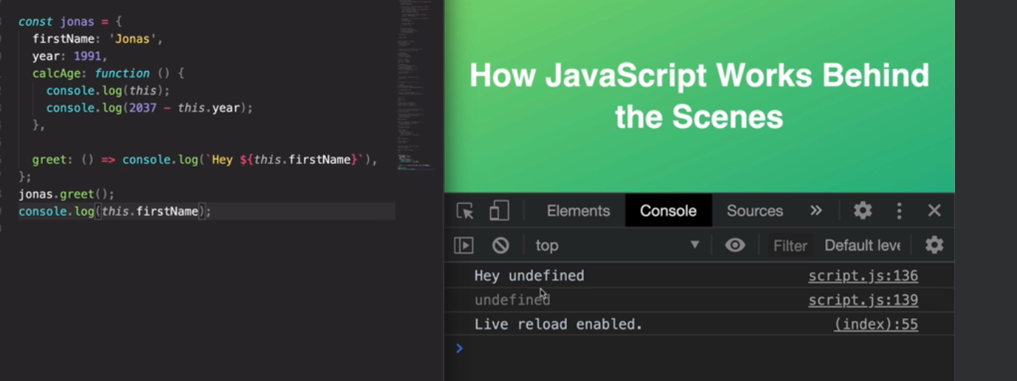

Since greet is arrow function in the above case, firstName is undefined. Here this is the window object where firstName is not defined.

Using var here is dangerous as shown below

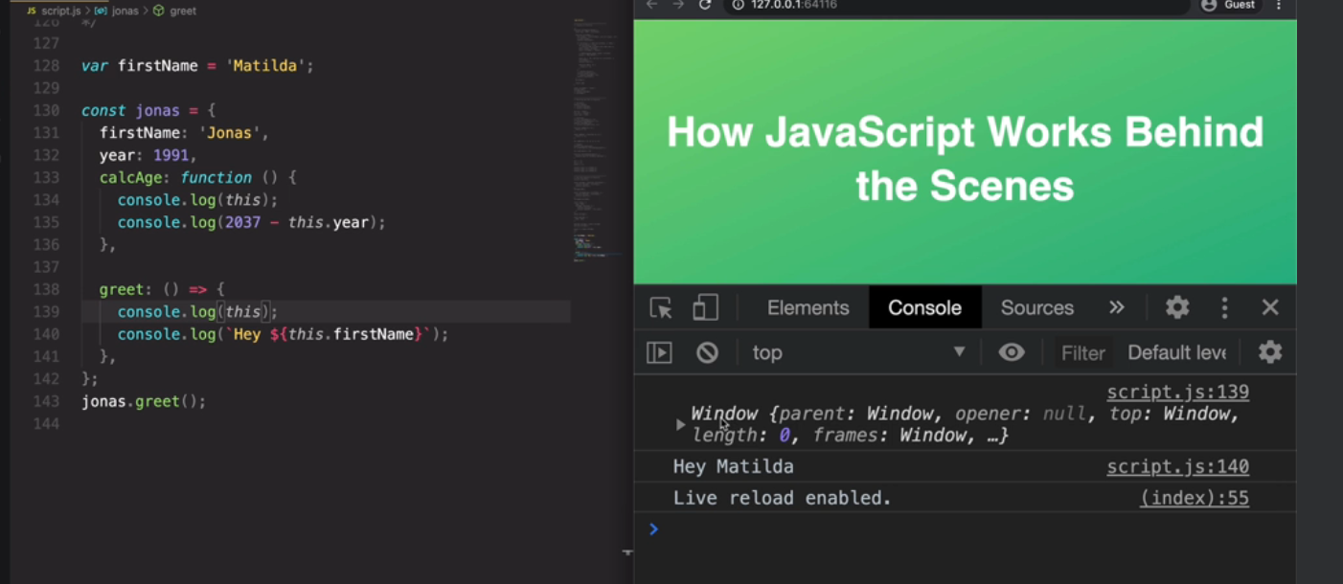

Even though isMillenial() call is within function it is a regular call, hence it is undefined. People think this is bug in javascipt which is not

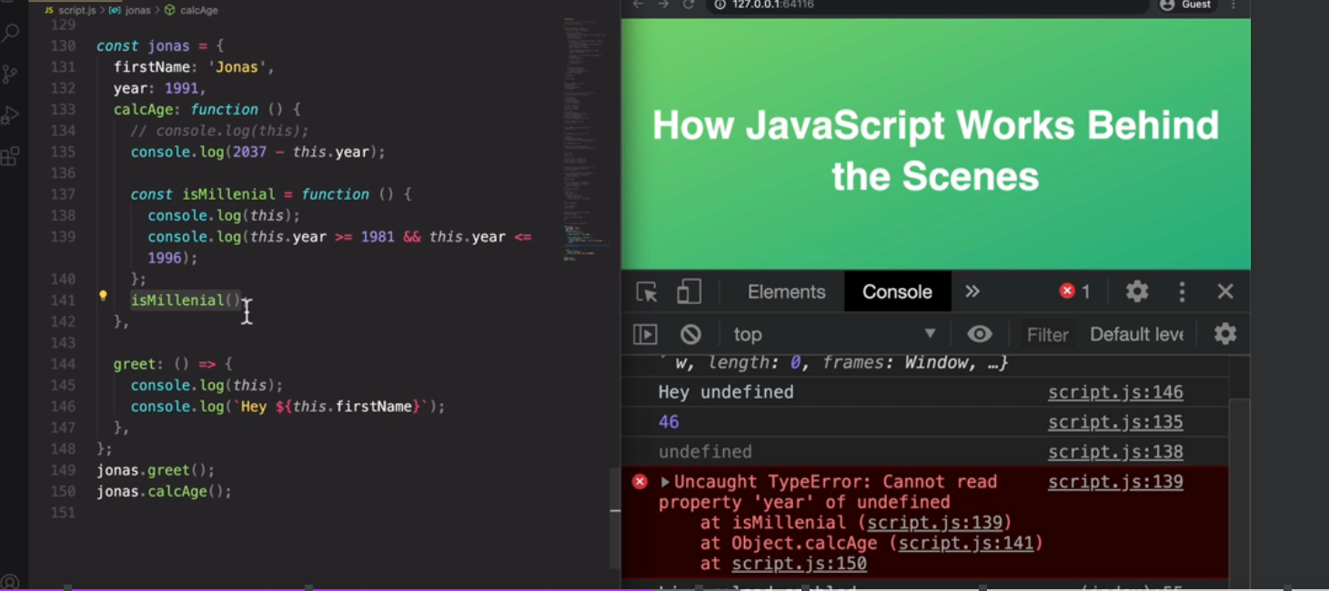

Solution:

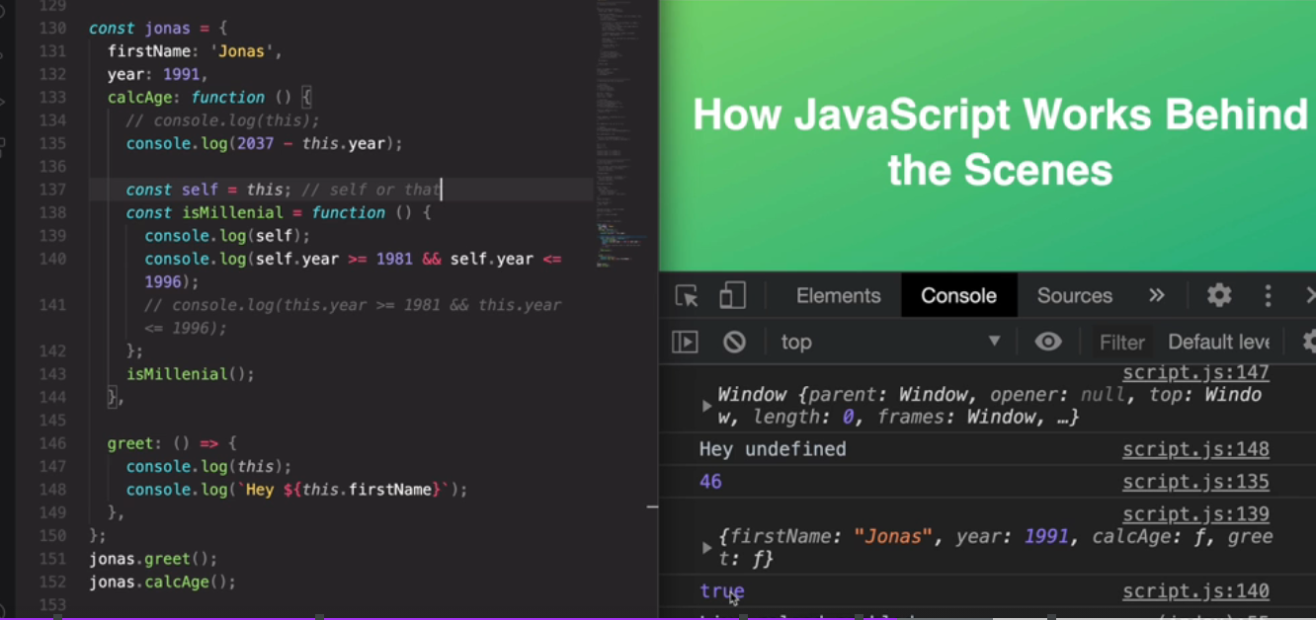

I also want to quickly touch on the arguments keywords. Maybe you remember me talking about that, also in a previous lecture. So in the video about execution context, and the call stack, we learned that functions also get access to an arguments keyword. So not just the this keyword, but also an arguments keyword. Now, just like the this keyword, the arguments keyword is only available in regular functions. So let's create another function here. So first an expression. So again, basically that's our functions for adding and actually let me just grab them from here. I think I defined them somewhere up here. Yes. So there's no need to rewrite the same code over and over again. Just add a comment here, arguments keyword. And then let me also print to the console, that keyword. So let me quickly call this function here now. So two and five so just so we see the arguments keyword. And so down here it is and you see that we get basically an array with two and five. And so that's exactly the two parameters that we passed in. And this can be useful when we need a function to accept more parameters than we actually specified. So this is something that we never did before. So up until this point, we have only ever specified exactly the arguments that we have here in the list of parameters. So we have two parameters, and so two arguments. But it is completely legal to add more arguments. They will not have a name, so we didn't name them, but they exist. And we can see them here in the arguments array. All right. So they do appear here, and we can use them therefore in the functions. For example, we could use a loop, and then loop over this array and add all the numbers together. But now my point here is that the arrow function does not get this keyword. So that's also log it to the console here so let's put this here in curly braces, then remember when we have more than one line of code, we need to explicitly return. And so let's try to take a look at the arguments keyword here as well. So add arrow two, five, eight, let's say, but then we get an error. So arguments is not defined. All right. So this was simply just to show you that the arguments keyword exists, but that it only exists in regular functions. So in function expressions like this, but also in function declarations, but not in an arrow function. But anyway, the arguments keyword is not that important in modern JavaScript anymore, because now we have a more modern way of dealing with multiple parameters. But still it's important that you are aware that this arguments keywords exists. All right, and now with all these lectures on regular functions and arrow functions, you should know all the differences between them, and even more importantly, when to use each of them.

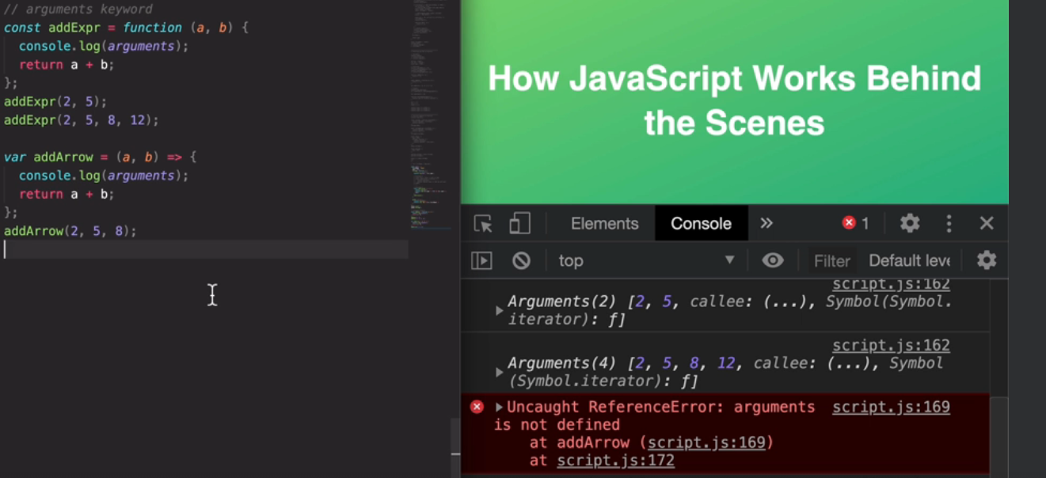

1. **Primitives vs objects**

Lets start with a simple example with primitives. And so remember primitives are like numbers, strings, Boolean's, et cetera. So simply setting the age to 30, and then I'm creating a old age variable. And this one I will set to the age because now it is my birthday basically. And so my age changes to 31, but I still wanted to preserve my old age here in this variable. Okay? So let's log the results to the console now. And they should be pretty much what we expect at this point. So you see that my current age is 31 because, well, I changed the original one from 30 to 31. But the old age is still 30 here. And that's because I set it here at this point of the code to age, which was still 30 at this point. And so then changing the age here from 30 to 31 did of course not affect the old age variable again. Again because at this point here age was still 30. All right, so here, hopefully there is not much confusion, everything works just as expected.

But now let's create another scenario which has an object. So I'm simply going to create an object for me, with the name of Jonas and age 30. And now let's copy this object because let's say that I have a friend who's also called Jonas. And so instead of creating a brand new object from scratch, I would just copy the me object. So const Friend equals Me. Okay? And so now both the name and the age are the same, but let's say that we have different ages. And so let's change the age of my friend and that's pretty straightforward, right? So let's say that he is 27 years old. But of course we did not change me.age, right? So let's now take a look at both of them in the console. So first my friend, so that's the Friend object and then also Me, or we could say Jonas, it doesn't really matter. But what matters is that we will see the Me object and what do we think will happen now? So let me show it to you. And now we get that both me and my friend have the age of 27. And that looks a little bit strange because all we did was to change the age of the friend, right? Nowhere here, I have me.age equals 27, but still for myself, so here at the Me object, the age is also 27.

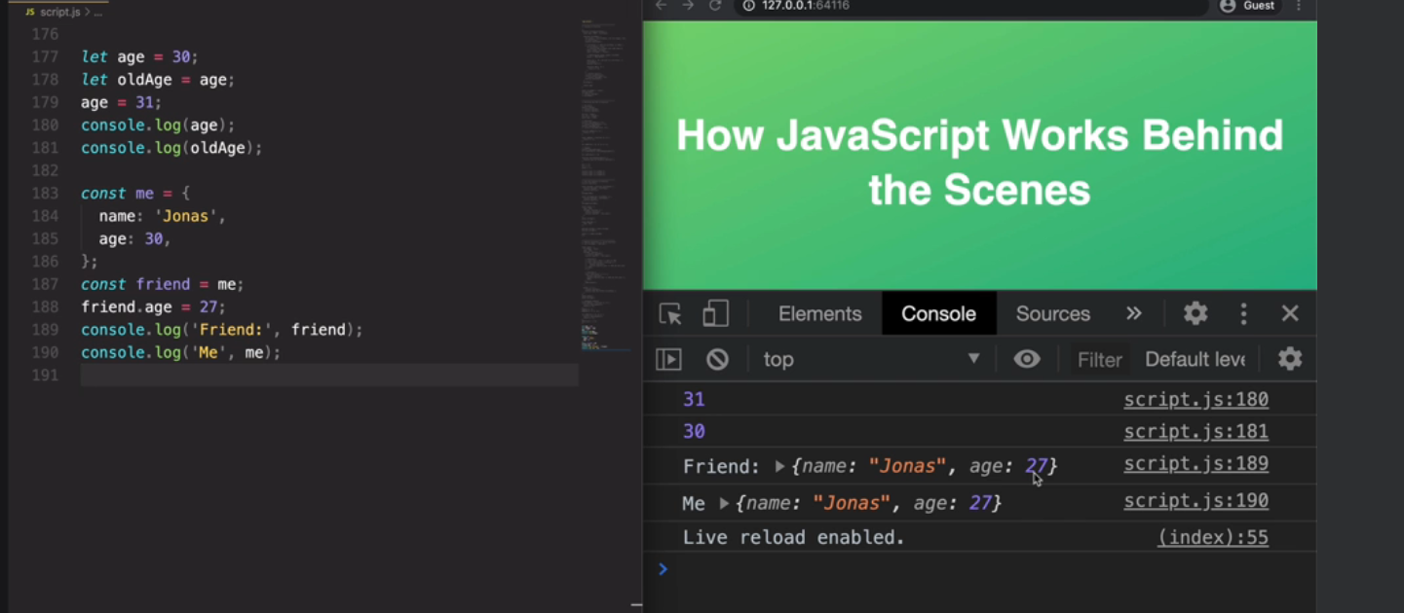

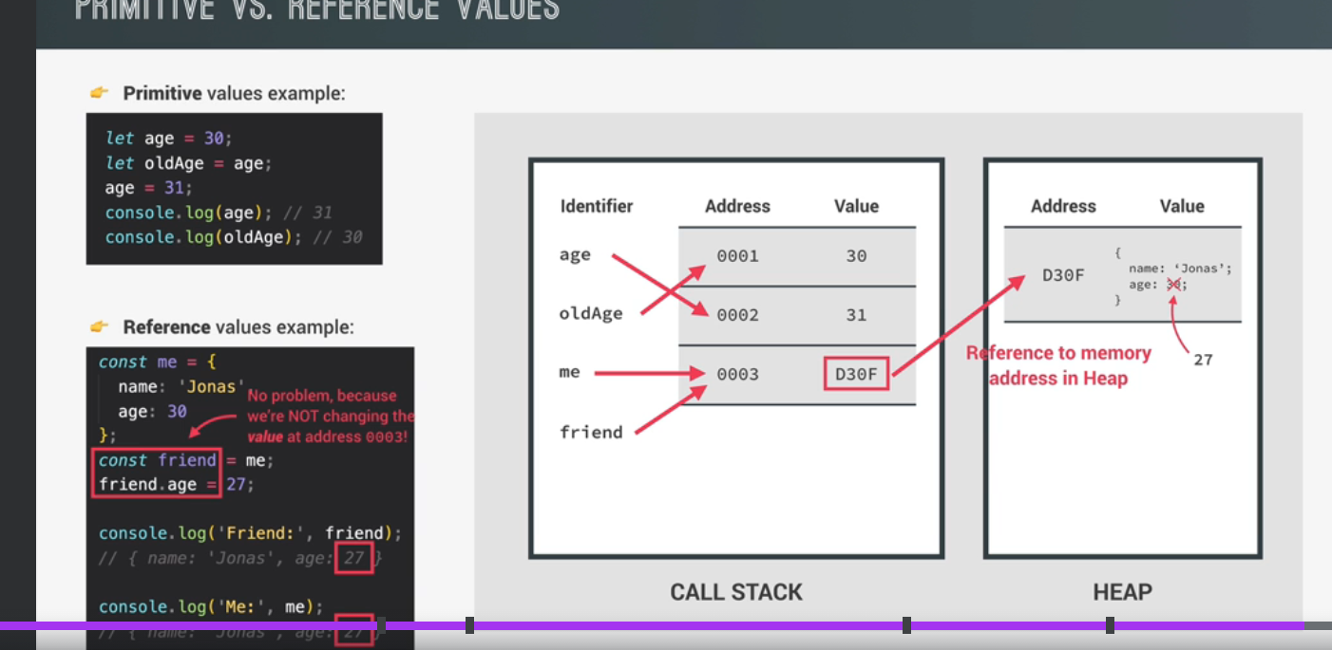

First, we need to remember about JavaScripts primitive data types, which are number, string, Boolean, undefined, null, symbol, and BigInt. Then everything else are basically objects. So objects created with the object literal, arrays and even functions are all objects. Now, when we're talking about memory and memory management, it's usual to call primitives, primitive types and objects reference types because of the different way in which they are stored in memory. Next, we need to remember about the JavaScript engine. So the engine has two components, the call stack, where functions are executed and to heap where objects are stored in memory. And that's right, all of objects, or in other words, reference types will get stored right in the memory heap. And I mentioned that when we first talked about the engine, but now you will finally learn how that actually works. On the other hand, primitives or primitive types are stored in the call stack. And with that, I mean that primitive types are stored in the execution contexts in which they are declared. But for the sake of simplicity, let's ignore that detail now. And simply say that primitive types are stored in a call stack because that's where execution context run. All right, but now how does all that actually work? And why did our code example earlier behave in that weird way? Well, let's find out. So here we have the two code examples from earlier, as well as the engine with call stack and heap. And let's start by looking at the primitive values example. So when we declare a variable like age equals 30, what actually happens inside the JavaScript engine and the computer's memory? Well, first JavaScript will create a so-called unique identifier with the variable name. Then a piece of memory will be allocated with a certain address, so 0001 in this example, and finally the value would be stored in memory at the specified address. So in this case, the value 30 will be specified at memory address 0001. And remember this all happens in a call stack where primitive values are stored. Now what's extremely important to understand here is that the identifier actually points to the address and not to the value itself. So we would say that the age variable is equal to 30, but in fact, age is equal to the memory address 0001, which holds the value of 30, all right? And this subtle distinction is very important to keep in mind. Now, in the next line, we declare old age to be equal to age. So knowing that a variable actually holds a memory address, what should old age look like? Well, it will simply point to the same memory address as the age variable. And so it will look like old age, is simply 30 as well. Great, but now in the next line, we set eight to 31. So what will happen then? The value at address 0001 will certainly not become 31 because that would change old age as well, since they both point to the same address. So that would make no sense at all. Also the value at a certain memory address is immutable, or in other words, it cannot be changed. So instead what's going to happen here is that a new piece of memory is allocated. So it's created and the age identifier now simply points to the new address, which is holding the new value of 31, all right? And that's why when we lock both or variables to the console in the end, they both return exactly values that we expect. Now with reference values, things work a bit differently, which is the reason why this example gave us that unexpected, weird behavior earlier in practice. So what's the origin of this weird unexpected result? Well, when a new object is created such as this Me object, it is stored in the heap. And such as before there is a memory address and then the value itself. Now in the case of reference values like this Me object the Me identifier does actually not point directly to this newly created memory address in the heap. So in this example, D30F, instead, it will point to a new piece of memory that's created in the stack. And this new piece of memory will then point to the object that's in the heap by using the memory address as its value. In other words, the piece of memory in the call stack has a reference to the piece of memory in the heap, which holds or Me object, okay? And that's the reason why we call objects reference types in this context. So again, when we declare a variable as an object, an identifier is created, which points to a piece of memory in the stack, which in turn points to a piece of memory in the heap. And that is where the object is actually stored. And it works this way because objects might be too large to be stored in the stack. Instead they are stored in the heap, which is like an almost unlimited memory pool. And the stack just keeps a reference to where the object is actually stored in the heap so that it can find it whenever necessary. Now, moving on in the code, we create a new variable called Friend that we set equal to the Me object. So what will happen here? Well, just like with primitive values, the Friend identifier will point to the exact same memory address as the Me identifier. And again, that address contains the reference, which then points to the object itself. And like this the Friend object is now essentially the exact same as the Me object. Do you see that here in the diagram? So here comes the interesting part because now we're actually gonna change a property in the Friend object by setting friend.age to 27. So what happens then is that the object is found in the heap, and the 30 is changed to 27. Great. And by the way, even though we defined the Friend variable as a constant, we can actually still manipulate the object without problems. And when we think about that, it makes sense because we're actually not changing the value in memory for the Friend identifier, it is still D30F. So the reference to the object. All we did was to change the value in the heap, and that's not a problem. So it's a misconception that all variables declared with const are immutable. In fact, that is only true for primitive values, but not for reference values. So keep that in mind, whenever you're working with const. Anyway, as we lock the Friend variable to the console, we get the age of 27, just as we said it before. But then when we lock the Me object, we get that weird behavior that we could previously not explain and not understand. But with everything that we learned in this lecture, it actually now makes sense that in the Me object, age is now also 27, even though we never changed me.age directly. And the reason for this, as we can see in this slide is the fact that Me and Friend actually point to the exact same object in the memory heap. So whenever we change something in this object, it will always be reflected in Friend and in Me. So in both these objects. So these are basically just two different identifiers pointing to the exact same value. And once again, that value is the memory address D30F which points to the reference in the memory heap. And one important implication of this is that whenever you think that you're copying an object, you're really just creating a new variable that points to the exact same object. And this has huge implications for the way JavaScript works in practice. And we will see that in the next video and throughout the course. Now there are actually ways around this, as we will also learn later. but in general, this is how reference values work in JavaScript. So make sure to really understand this, as well as the implications that this behavior has, even if that means that you have to re-watch this lecture or at least the explanation of this slide, all right? Then once you really understand what happened here, in this example, let's understand primitive values and reference values even better in practice in the next lecture. But before we do that, let me just quickly take a second and mention a three more, really big topics about how JavaScript works behind the scenes that will not be in the section, but closer to where we actually need to learn about them. For example, one fundamental concept of JavaScript is prototypal inheritance. But we will only talk about that in the object oriented programming section of this course. Because it doesn't make sense to learn about this now only to then forget it all until we finally reach that section. The same is true for a detailed lecture on the event loop. So I already introduced the event loop in this section, but in the section about asynchronous JavaScript, we will dive really deep into how exactly the event loop works and why it's such a fundamental piece of the JavaScript engine. Finally, we will have lectures on how the DOM actually works behind the scenes too. And that's going to be in the advanced DOM and events section so that you can then apply what you learned there right away. Okay? And with that being said, let's now move on.

Problem:

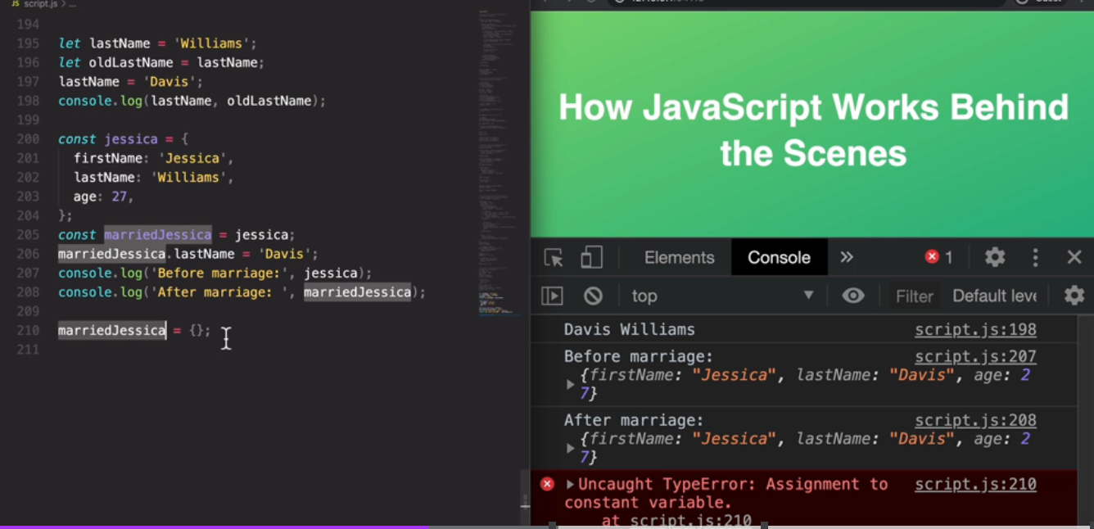

Solution:

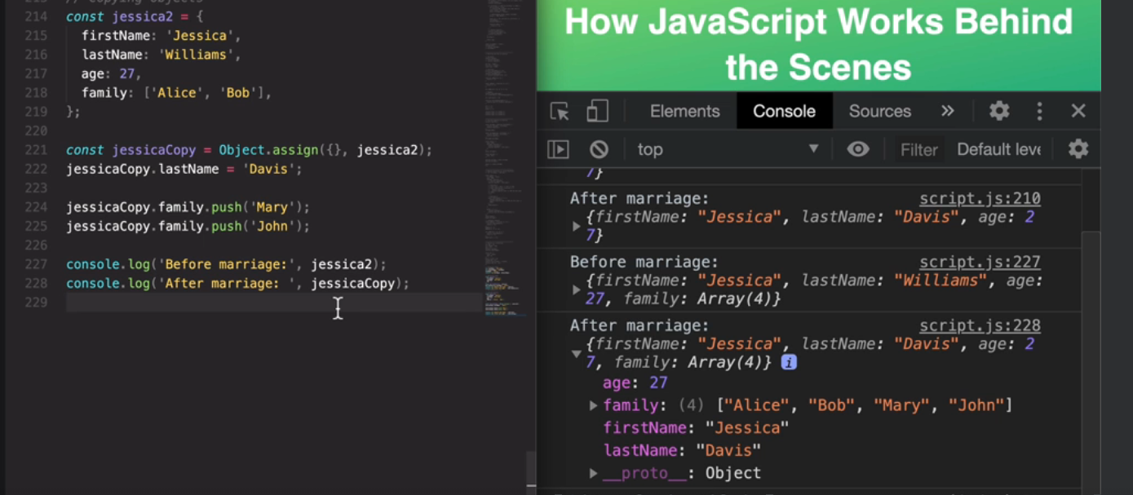

1. **Destructuring array**

Copying array to constants

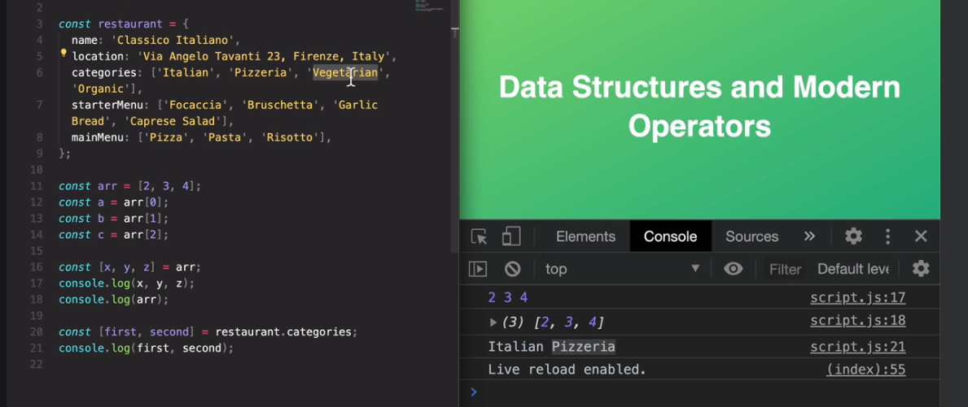

Swapping elements:

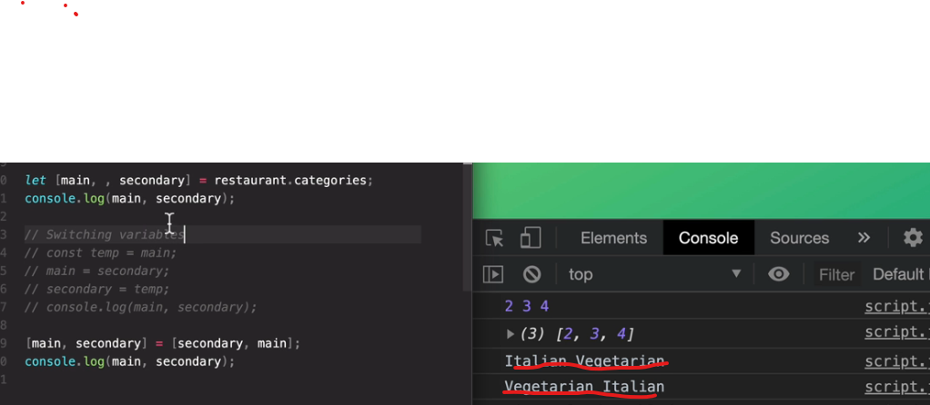

Fetching attribute of object through a function and assigning to variable: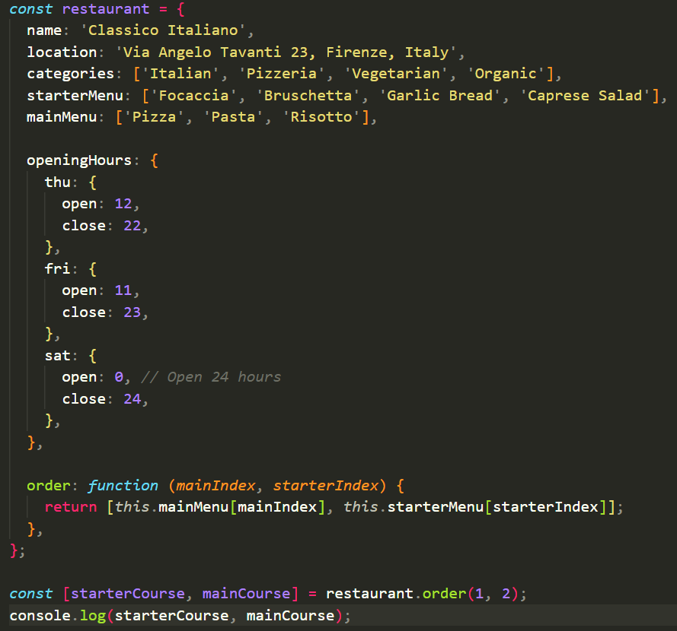

Nested destructuring:

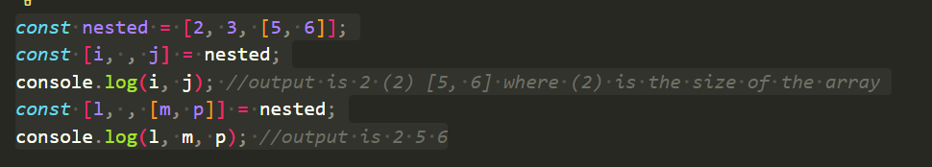

Default values:

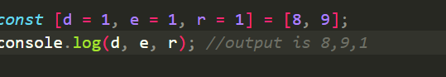

1. **Destructing objects**

We use curly brackets to destructure objects.

The name in variable should exactly match the variables from the object.

Since order in object does not really matter, we no need to skip obj like array.

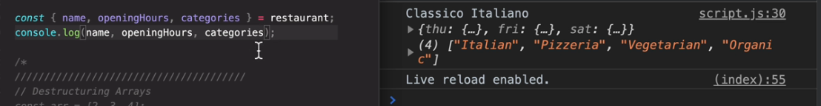

aliasNames for object variables:

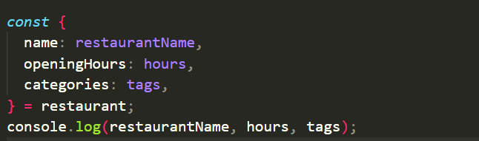

Default values:

We would get undefined if we do not give default value

In below scenario there is no variable such as menu in resutrant obj,hence takes empty array

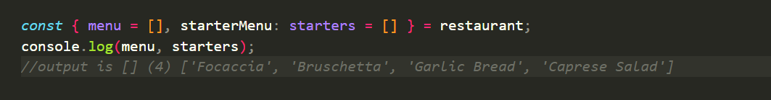

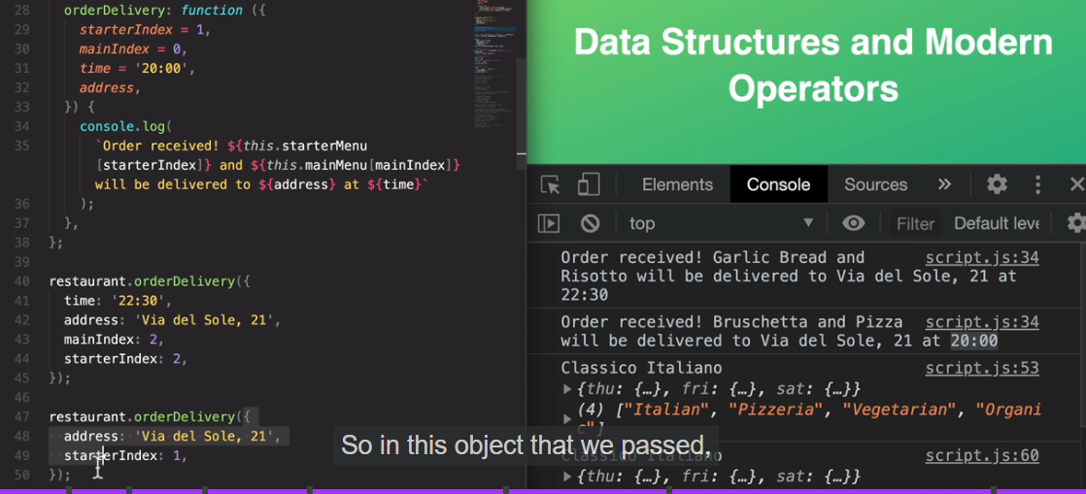

Mutating variables with objects:

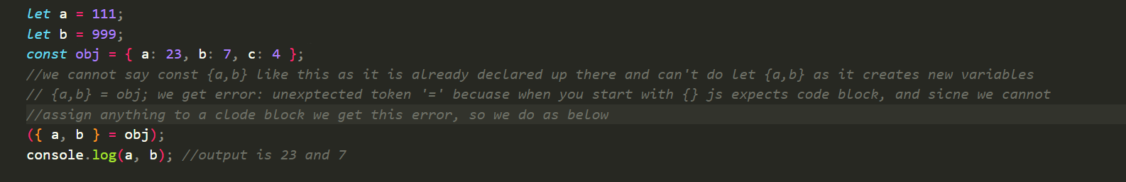

Nested objects:

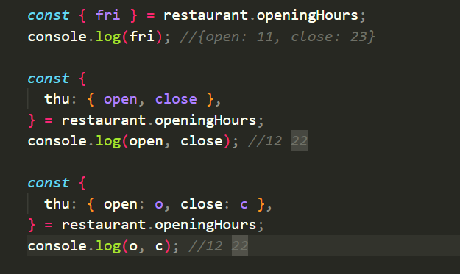

Here in below example we only passed one object in the function orderDelivery not four arguments. In the function as soon as we received the object we immediately deconstructed the object even though order is not same but properties name should be matching.

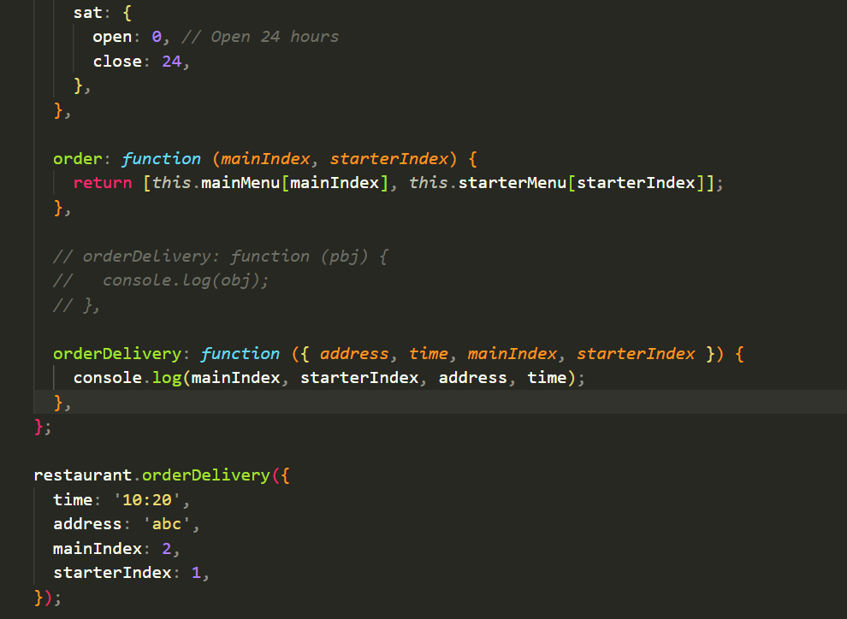

1. **Spread operator**

Used to unpack all the elements of the array into one.

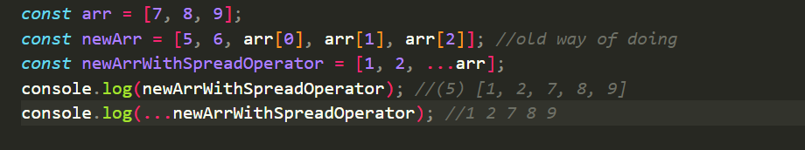

Copying array is on of the main use of this operator:

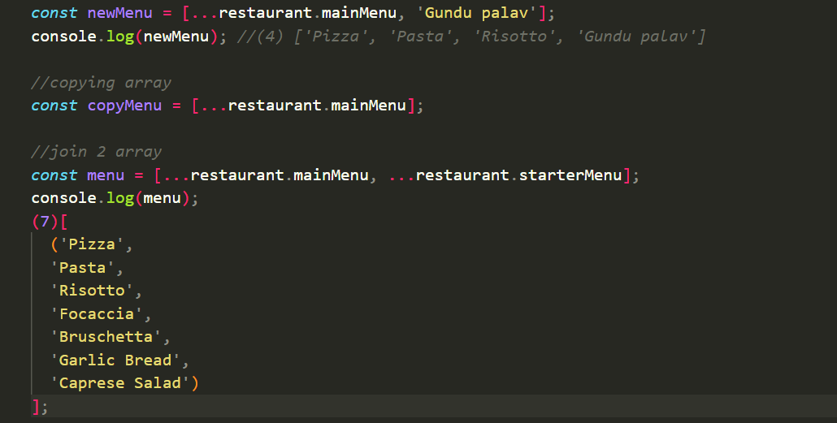

Iterables: array, string, maps, sets are iterables. Object is not

Spread operator is applicable to iterables.

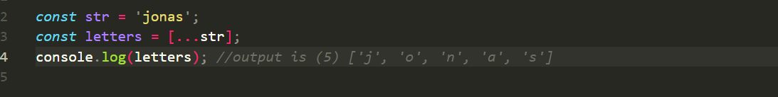

Passing spread operator as arguments:

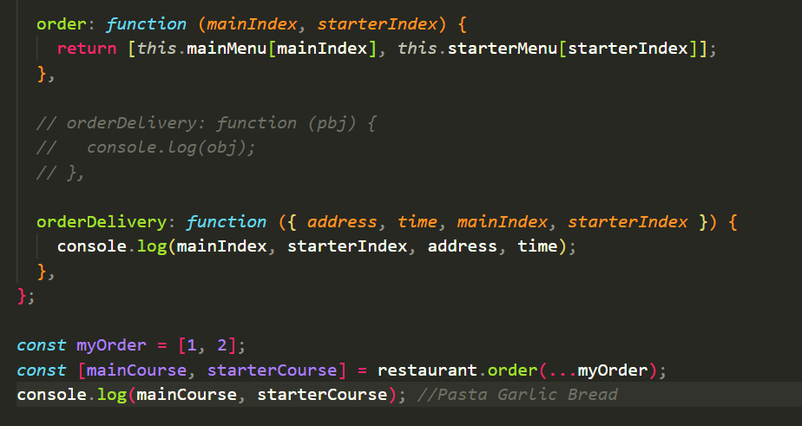

Lets create new restaurant object but with some additional data:

We do shallow copy of objects and arrays using spread operator

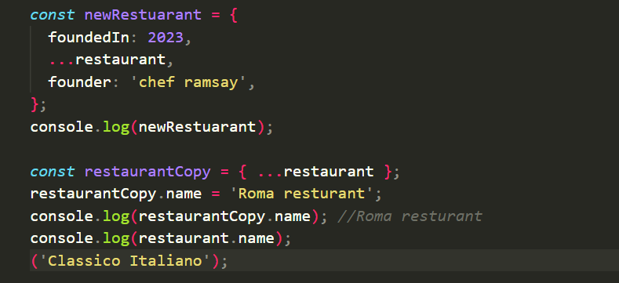

1. **Rest pattern and parameter**

Rest patterns as same syntax as spread operator but exactly does opposite of it.

In this case, to collect multiple elements and condense into an array

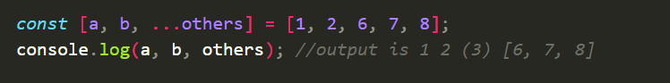

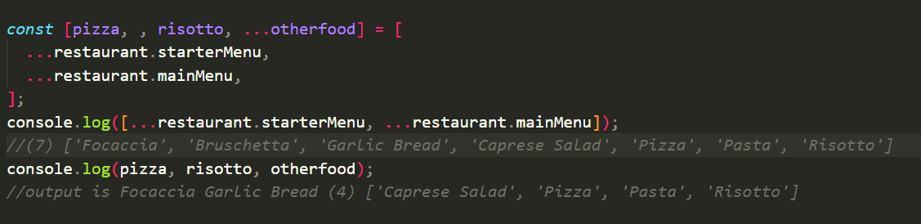

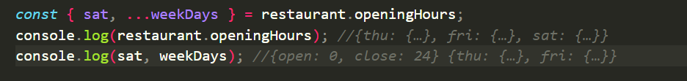

In function rest pattern taking collection as argument:

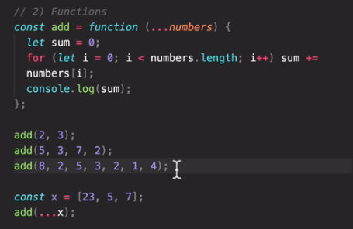

Taking null in argument and more values:

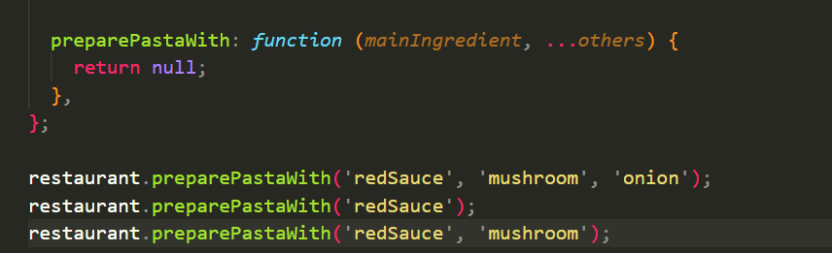

1. **Short circuiting (&& and || )**

And and OR operator are used to combine Boolean values. We can do more as shown below:

Here 3 is true, hence output is 3..

* the output does not need to be Boolean always
* based on truthy value which is 3, it is return in OR operator case

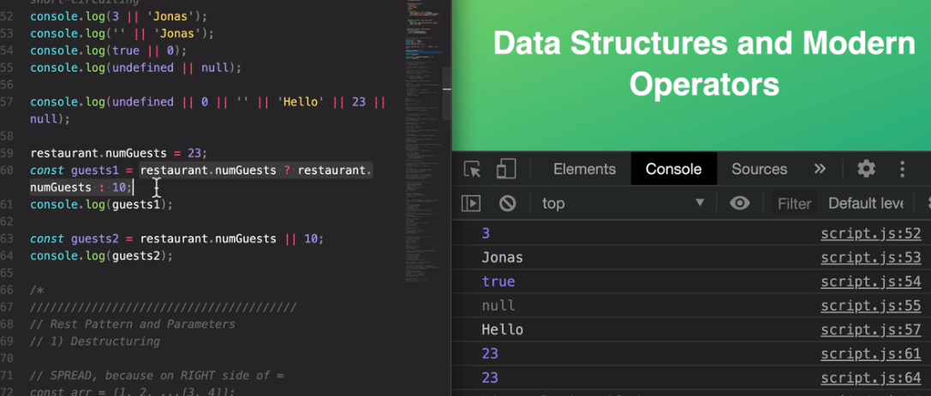

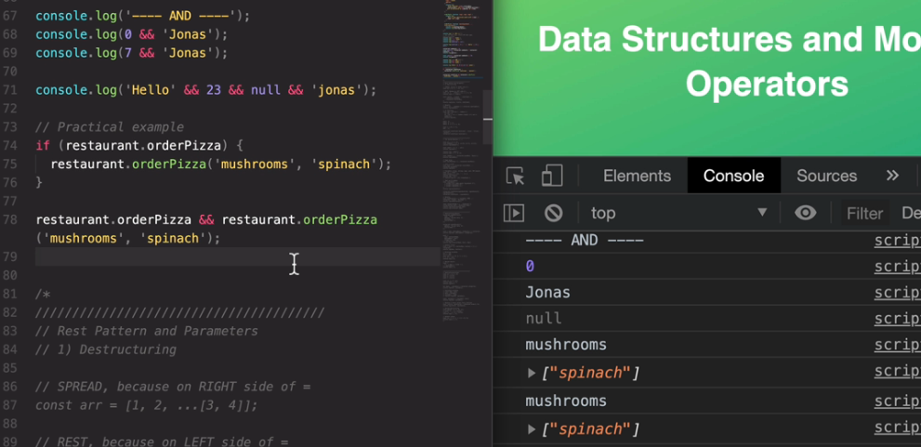

1. **The nullish coalescing operator(??)**

We would set an default value in case the actual value is null.

* Instead we can prefer nullish coalescing operator which works on the concept of nullish values instead of falsy values**.**
* Nullish values are null and undefined ( not 0 or ‘’)

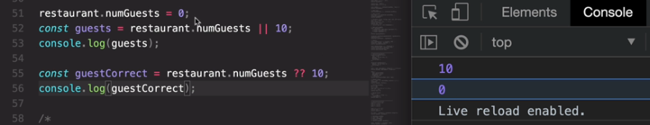

Now let’s remove numGuests initialization or make it null.

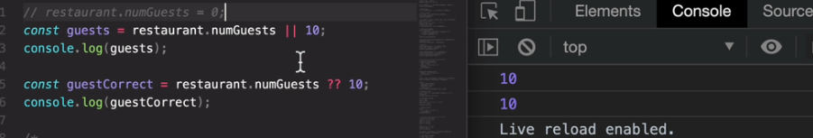

1. **Optional Chaining**

To avoid throwing error.

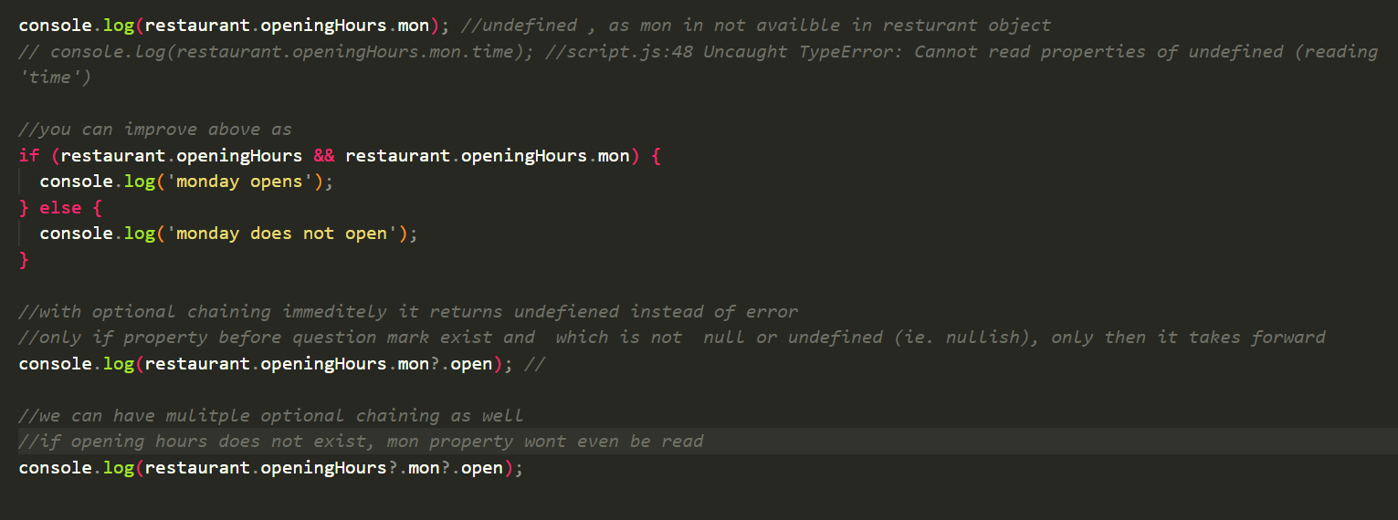

On array: checks name only if object at index zero exist in array

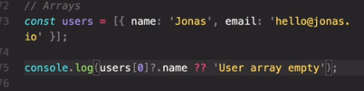

1. **Working with arrays**

* **Slice**

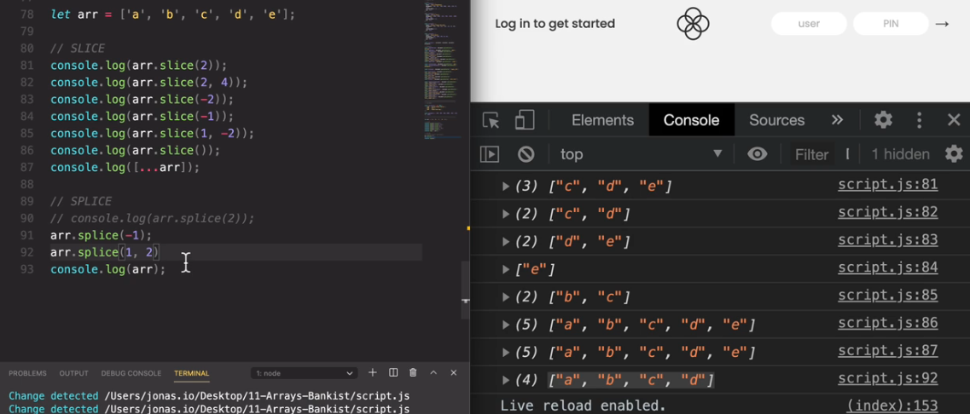

* **At method** gives the object 64 where are arr.slice(-1) give [64].

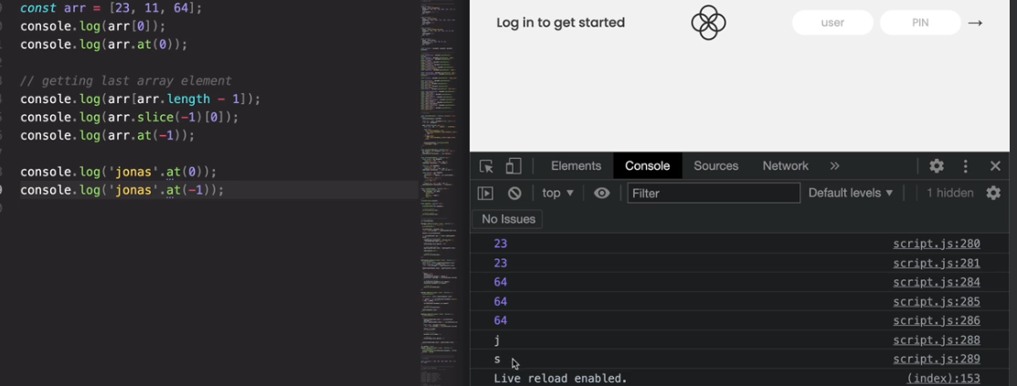

* **forloop** and **forEach**.

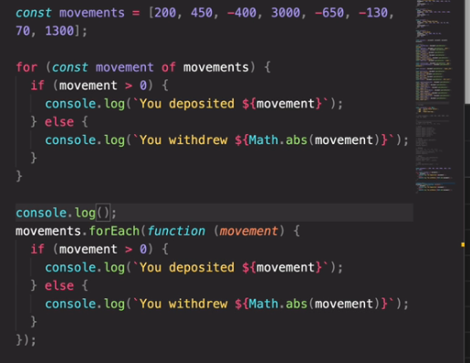

Entries an method of array returns the counter and the object as follows:

And so let's now do the same in the forEach method here.And here, fortunately, it's a lot easier to get access to the current index.

So to understand how it works we need to remember once more that it is the forEach method who calls this callback function in each iteration.

And as it calls this function it also passes in the current element of the array,but actually that's not all it passes in in fact forEach passes in the current element,the index and the entire array that we are looping.

And so therefore we can specify them here in our parameter list.

So let's say index and array,now of course we can just use one, like we have been doing,or we can just use two,or we can use all three together.

And as always the names here do not matter at all,but what does matter is the order.So the first parameter always needs to bethe current element,the second parameter always the current index and the third one always the entire array that we are looping over.

Because that's the order in which the arguments,so the actual values, are passed into our callback function.

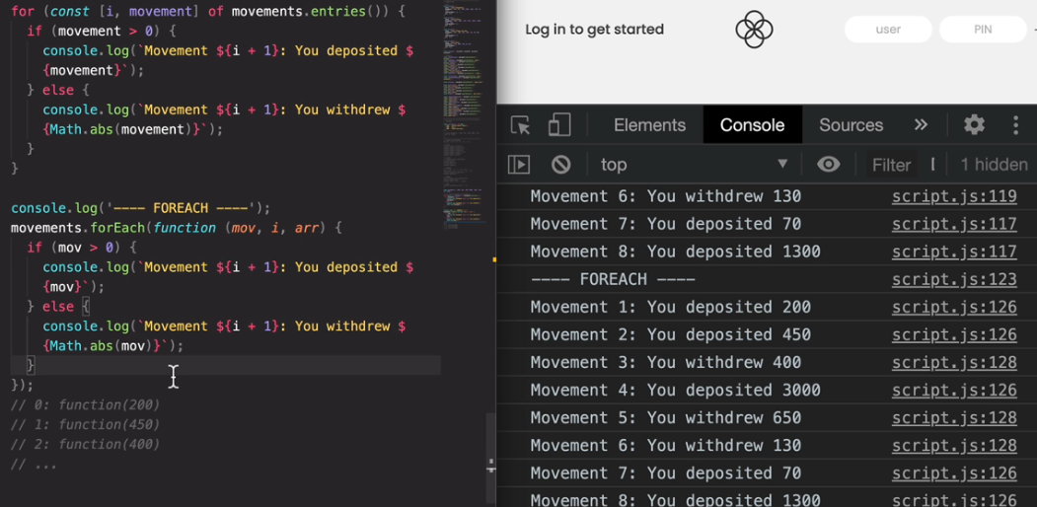

* **forEach for Maps**.

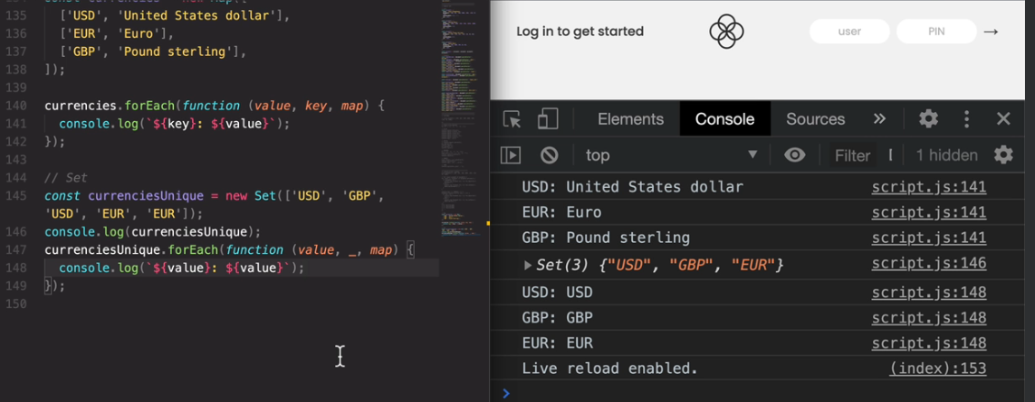

Project:

Lets start with a simple example with primitives.

1. **Advanced DOM and Events**

* Section Roadmap

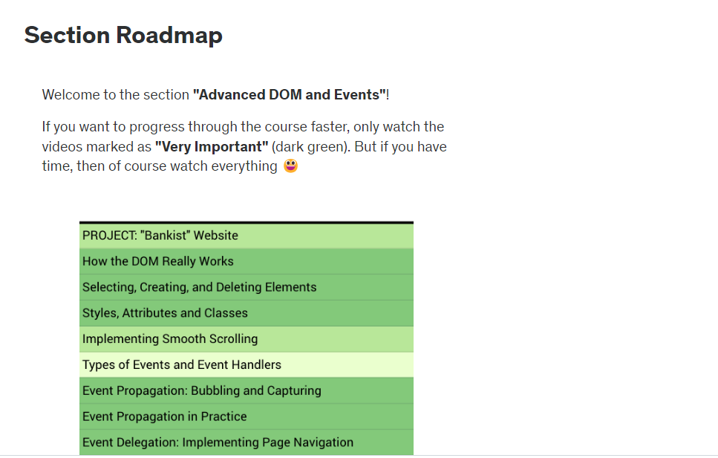

* DOM

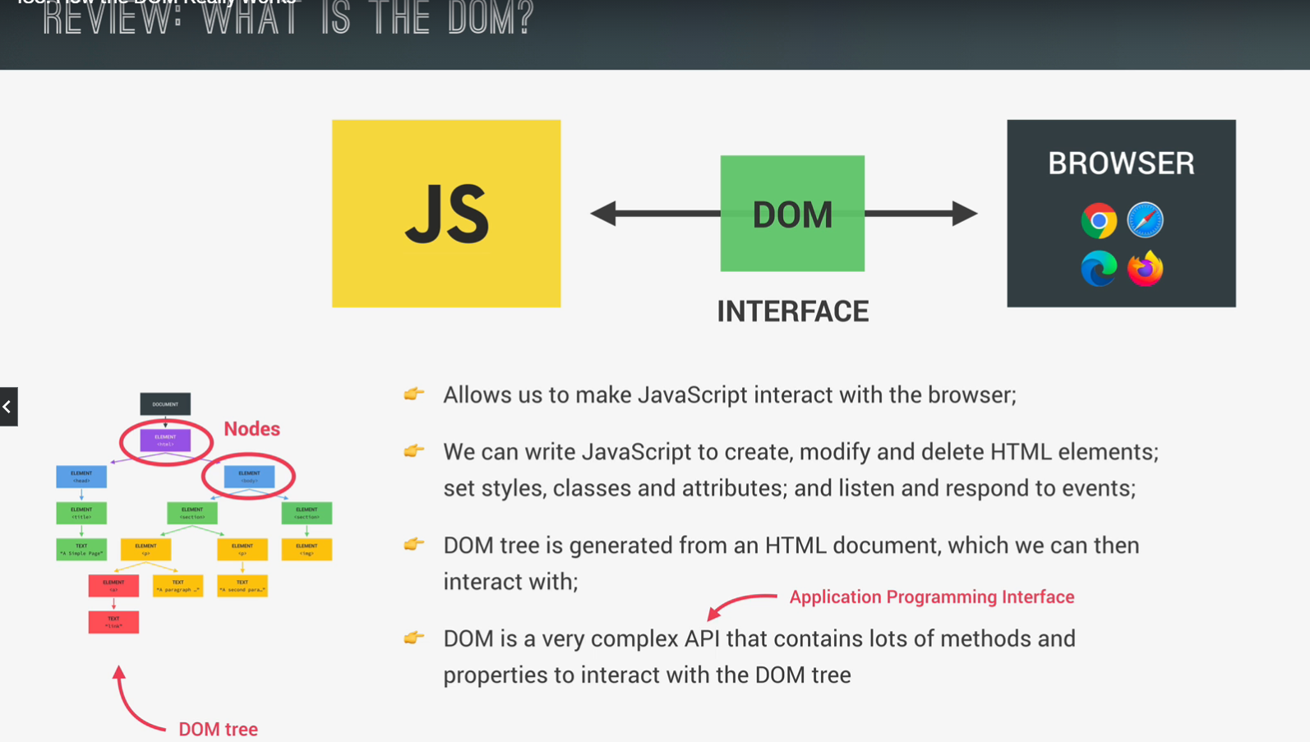

* How the DOM API is organized

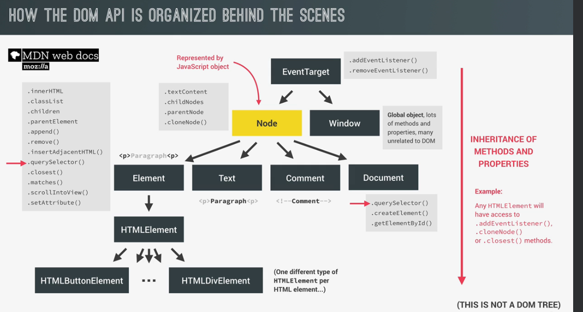

* Selecting elements

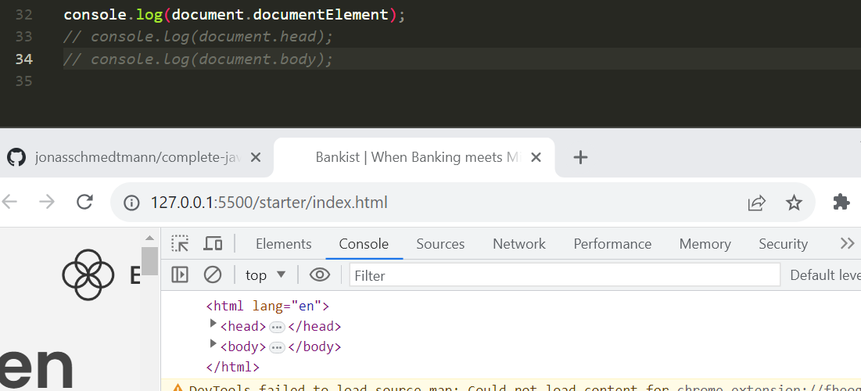

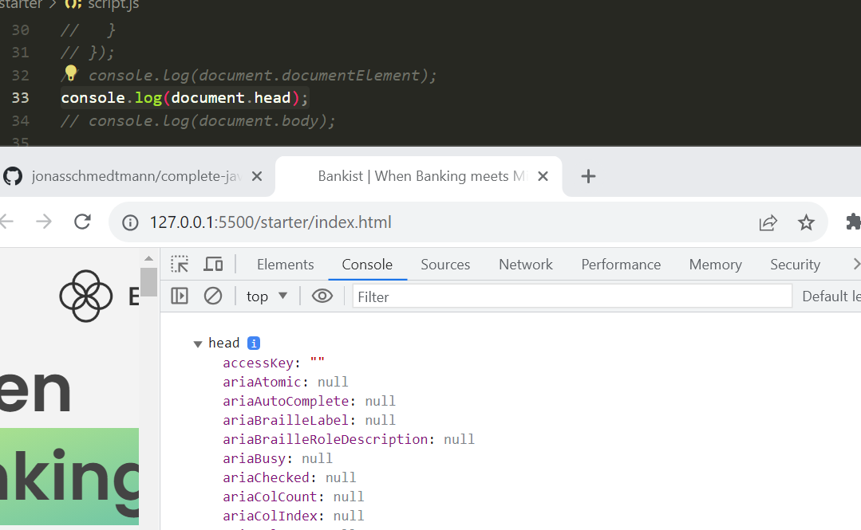

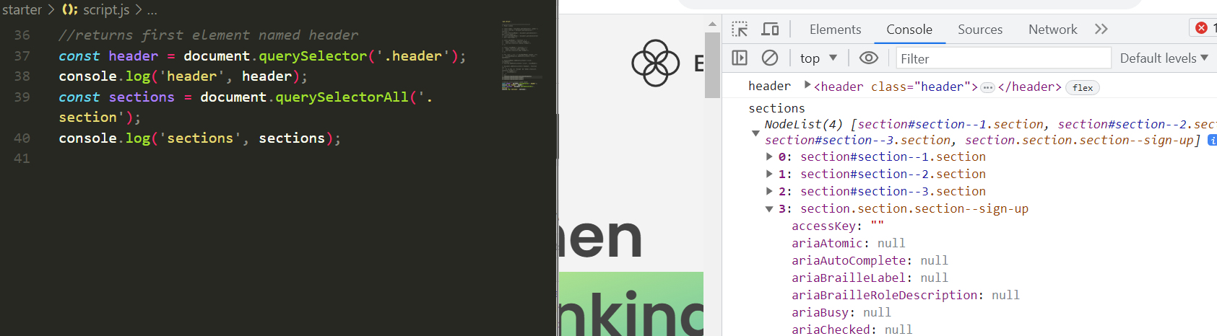

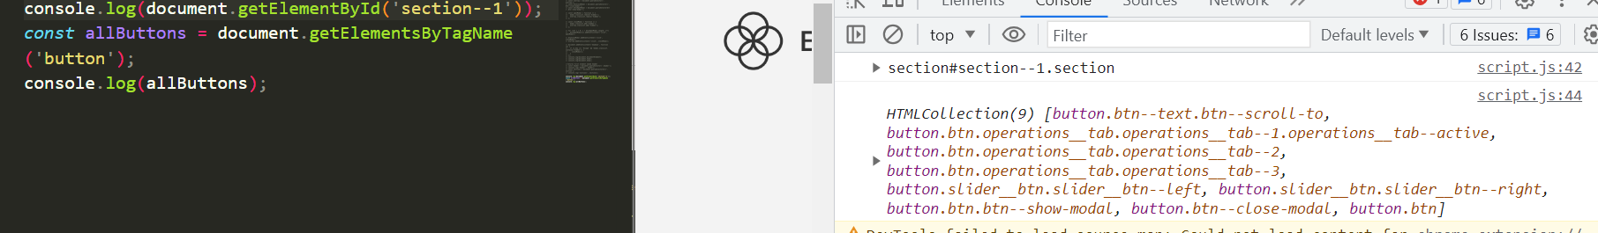

Now, what I wanted to show you is that this method actually returns an HTML collection.So that's different from a node list because an HTML collection is actually a so-called life collection. And that means that if the DOM changes then this collection is also immediately updated automatically.

So for example, if I remove this button here and I can do that by clicking inspect and then that will select that button here then all I need to do is to hit delete and then if I go back here to the console and try to read the allButtons again then you see that we only have eight elements in here. while before we had nine, right? Same thing does not happen with sections which are node elements

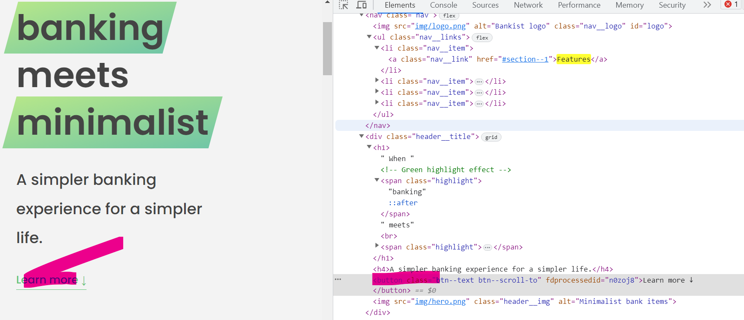

* Creating and inserting elements

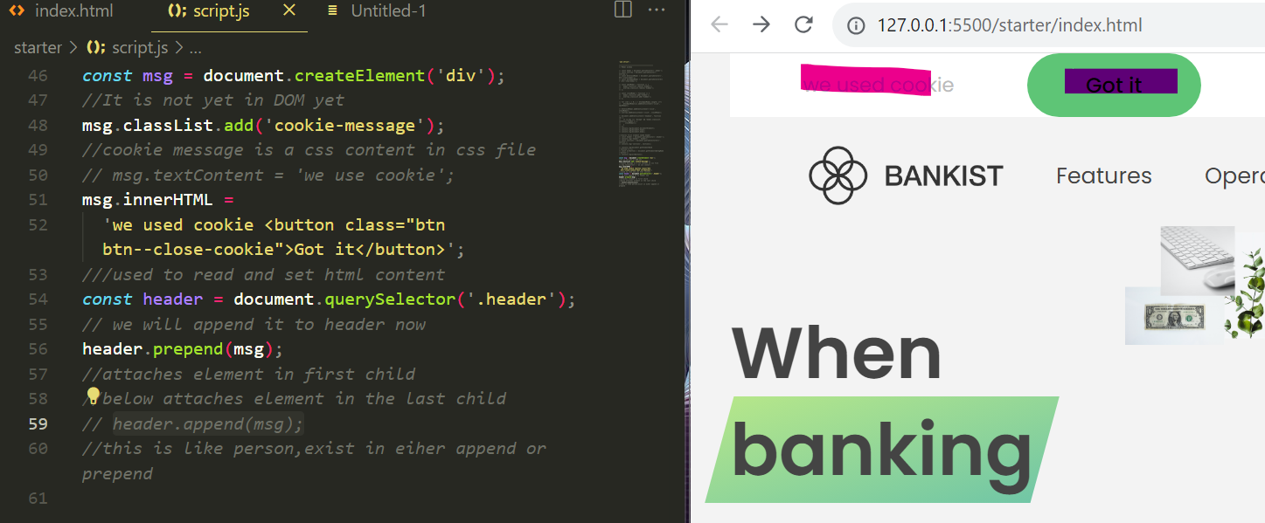

* Deleting elements

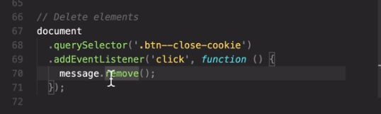

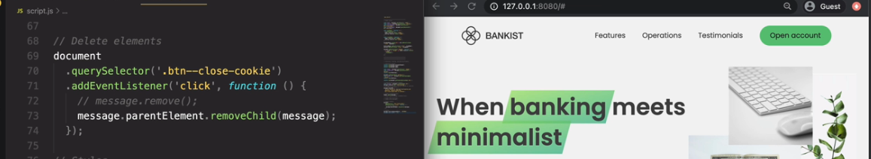

* Styles, attributes and classes

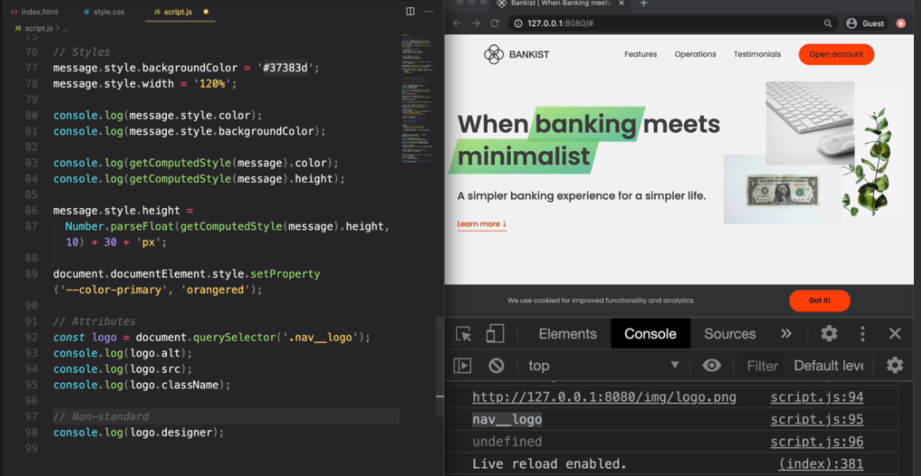

* Dsfs

1. **Asynchronous javascirpt: Promises, Async/Await & Ajax**

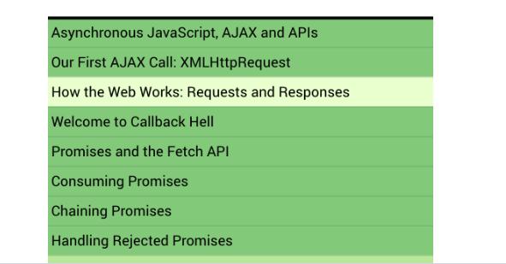

setTimeout makes the code Asynchronous , as other function execute while the function withing timeout runs in the background

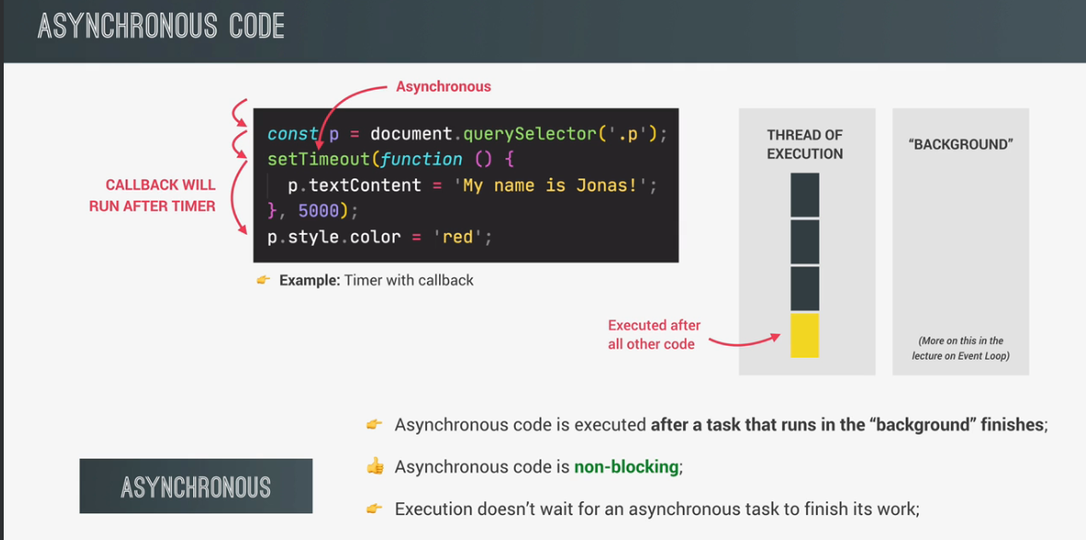

* we need a callback function to implement this asynchronous behavior, right? However, that does not mean that callback functions automatically make code asynchronous.Event map() uses callback but it is not asynchronous but setTimeout is.
* Image loading through “src” is a asynchronous in javascript
* Ajax stands for asynchronous JavaScript and XML,and basically it allows us to communicate with remote web servers in an asynchronous way.

Ajax call:

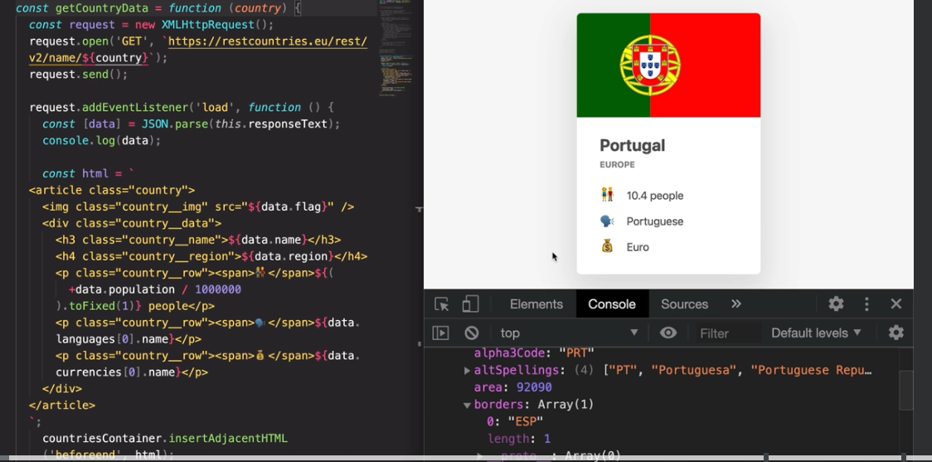

How request and response exchanged:

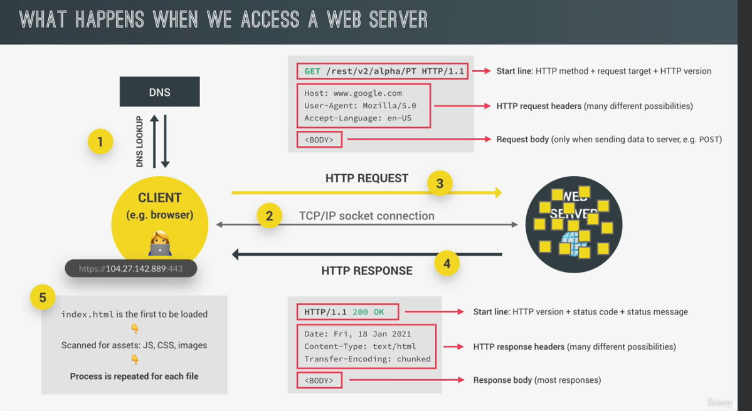

CallBack hell:

* Here in the below scenario we are fetching a country detail, calling render method to display it and continue to fetch the neighbouring country detail and render that as well in the same function.

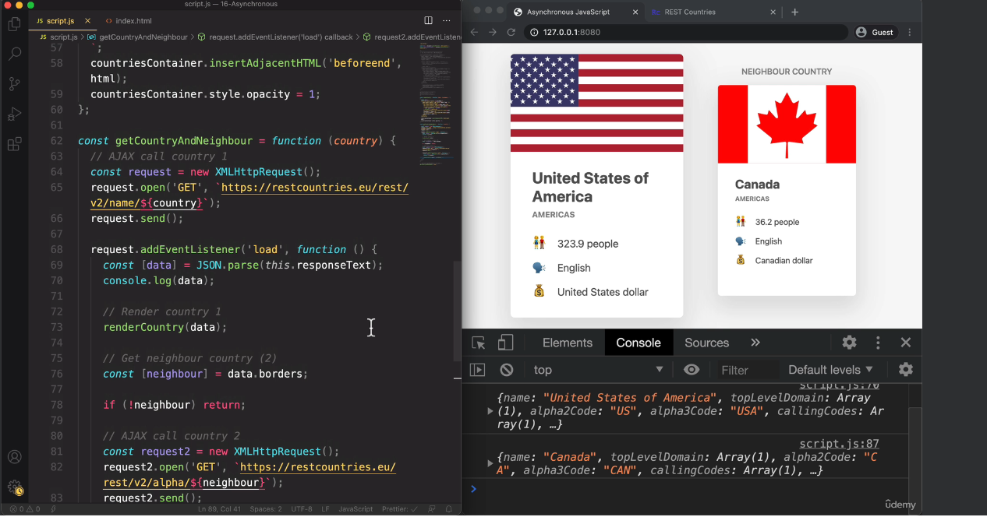

* Now imagining we have 10 neighbours where we make asynchronous call in synchronous way. This is called callback hell.
* So basically, callback hell is when we have a lot of nested callbacks in order to execute asynchronous tasks in sequence. And in fact, this happens for all asynchronous tasks, which are handled by callbacks.
* Below is also an example of callbackhell with timer

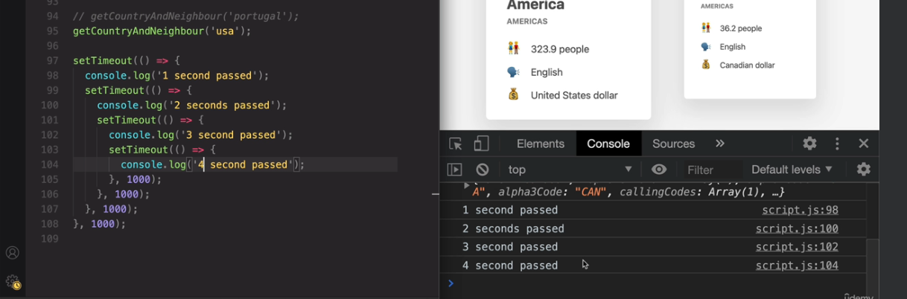

Promises and the Fetch API:

* Promises are used to escape callback hell.
* We can achieve it using fetch , a function which immediately returns a promise as shown here and it says pending.
* So, the formal definition of a promise is that it's an object that is used basically as a placeholder for the future result of an asynchronous operation.

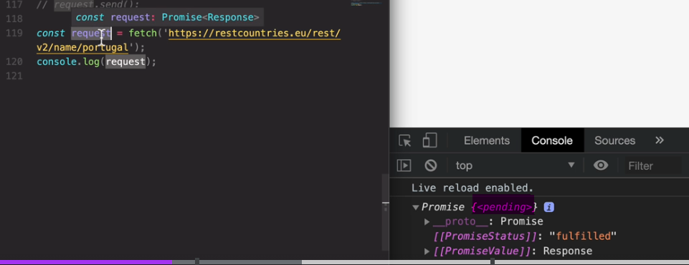

* Now, since promises work with asynchronous operations, they are time sensitive. So they change over time. And so promises can be in different states and this is what they call the cycle of a promise.

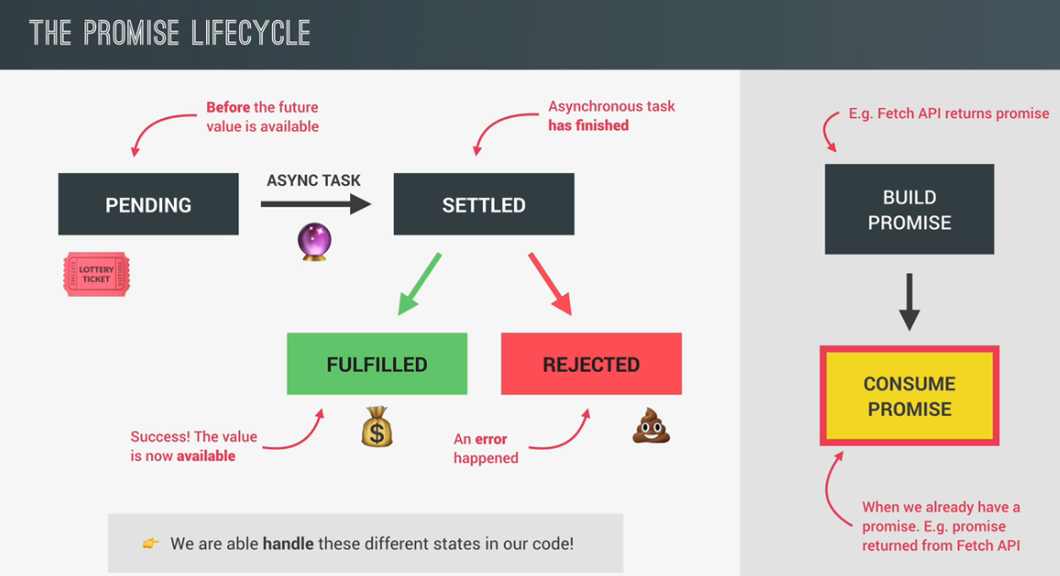

Consuming the promise:

* Lets assume promise gave a fulfilled response. On every promise we can call ‘then’ method.
* Now into the then method, we need to pass a callback function that we want to be executed as soon as the promise is actually fulfilled.
* As soon as the result is available this function will receive one argument which the result value of the fulfilled promise.
* We need to call the json() method on response to get the body
* Json method is also a asynchronous function which means it also returns a promise. So we need to return it.
* Then, since it is a promise we need to call it using then and another call back function with data.
* Note that response and data are callback functions, promises does not get rid of callbacks but definitely callback hell.
* So actually the then method always returns a promise,no matter if we actually return anything or not.But if we do return a value,then that value will become the fulfillment value of the return promise.

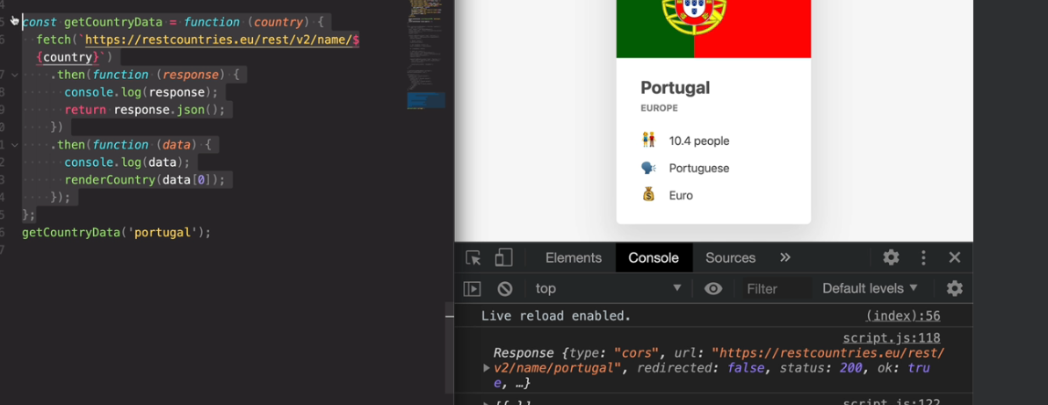

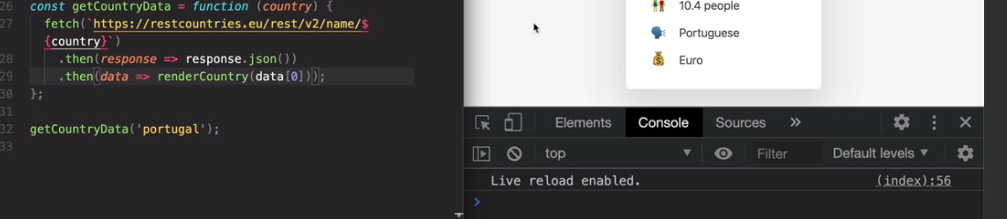

Chaining Promises:

* So actually the then method always returns a promise,no matter if we actually return anything or not.But if we do return a value,then that value will become the fulfillment value of the return promise.
* Here what we have his promises chain than callbackHell

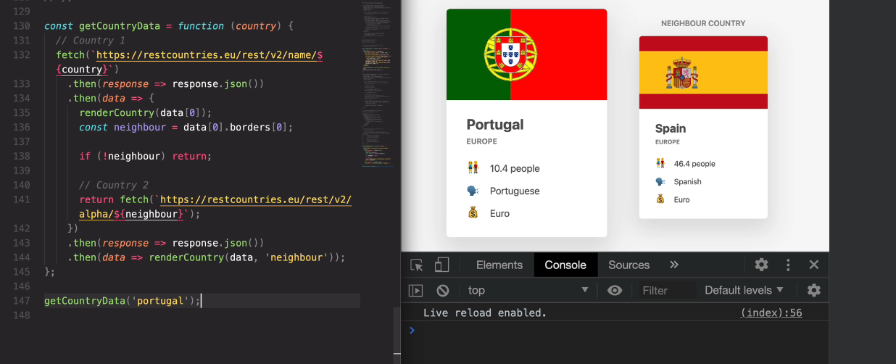

* Doing this again becomes a callback hell

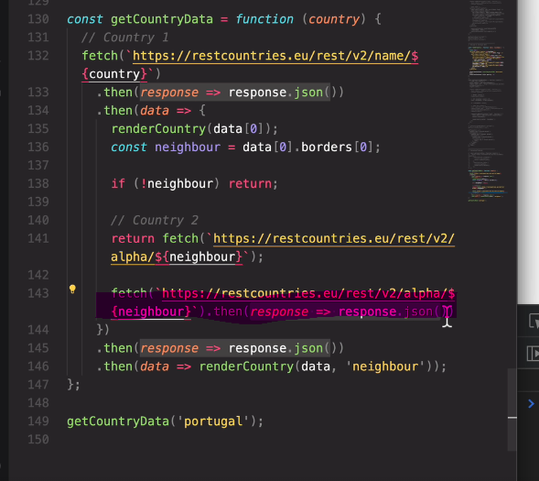

Handling reject promise:

* We can catch error like shown below

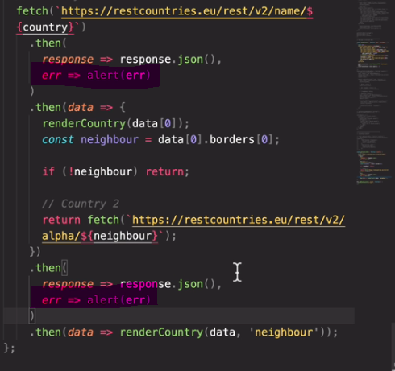

* But it is always better to catch it globally as shown below

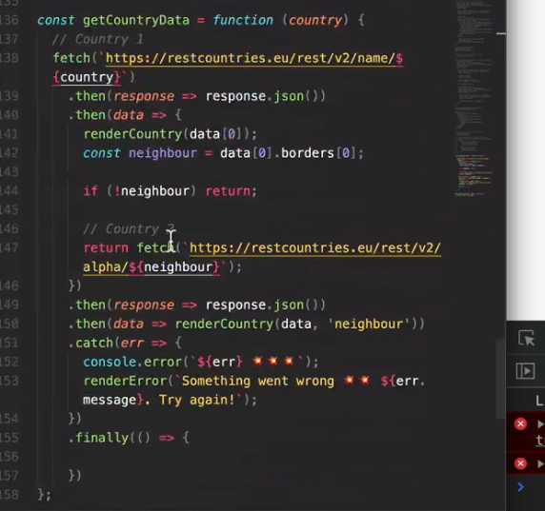

Throwing error manually:

* You can see, in response since we added console, we need to use ‘ return’ keyword as it is not the only line in callback function
* Some errors will not be caught by catch block and throws undefined error which has to be caught manually
* As you can see in the console response attribute which is ok that returns a Boolean value, based on which we can throw manual error
* Once you throw error basically the promise becomes a rejected promise and it directly goes to catch block

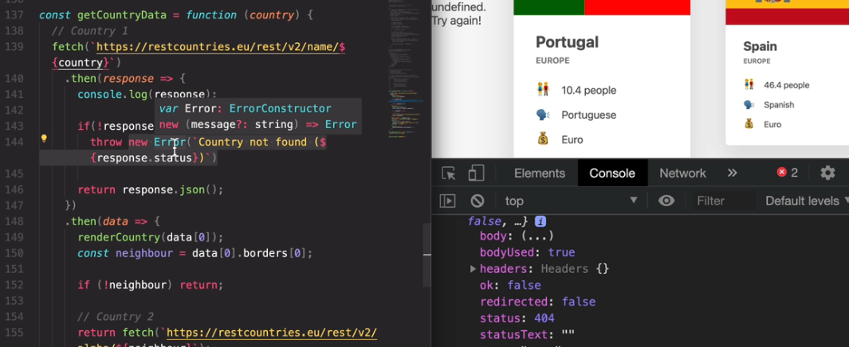

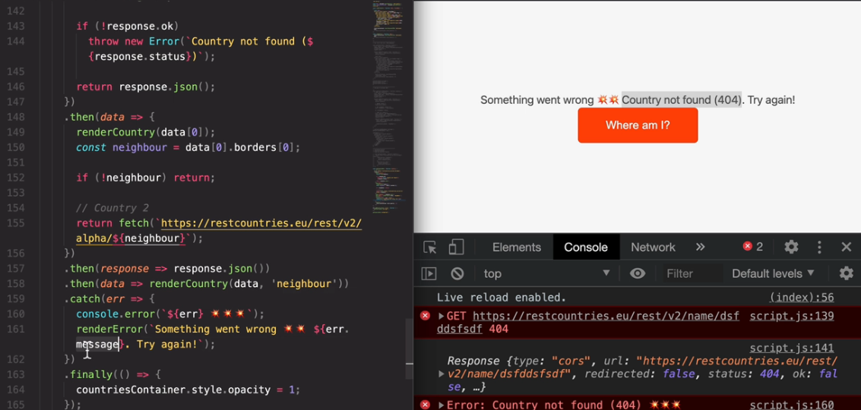

Asynchronous Behind the scenes: The Event loop

How all asynchronous functions like promise and callback really works behind the scenes of JavaScript?

So, a JavaScript runtime is basically a container which includes all the different pieces that are necessary to execute JavaScript code.

Now, the heart of every JavaScript runtime is the engine where code is actually executed and where objects are stored in memory.

So, these two things happen in the call stack and in the heap.

Now, what's important to note here is that JavaScript has only one threat of execution. And so it can only do one thing at a time.

There is absolutely no multitasking happening in JavaScript itself. Now, other languages like Java can execute multiple pieces of code at the same time, but not JavaScript.

But anyway, next we have the web APIs environment. These are some APIs provided to the engine, but which are actually not part of the JavaScript language itself.So, that's things like the DOM timers the fetch API, the geolocation API, and so on and so forth.

Next up, there is the callback queue and this is a data structure that holds all the ready to be executed callback functions that are attached to some event that has occurred.

Finally, whenever the call stack is empty the event loop takes callbacks from the callback queue and puts them into call stack so that they can be executed.

So the event loop is the essential piece that makes asynchronous behavior possible in JavaScript.

It's the reason why we can have a non blocking concurrency model in JavaScript.And a concurrency model is simply how a language handles multiple things happening at the same time.

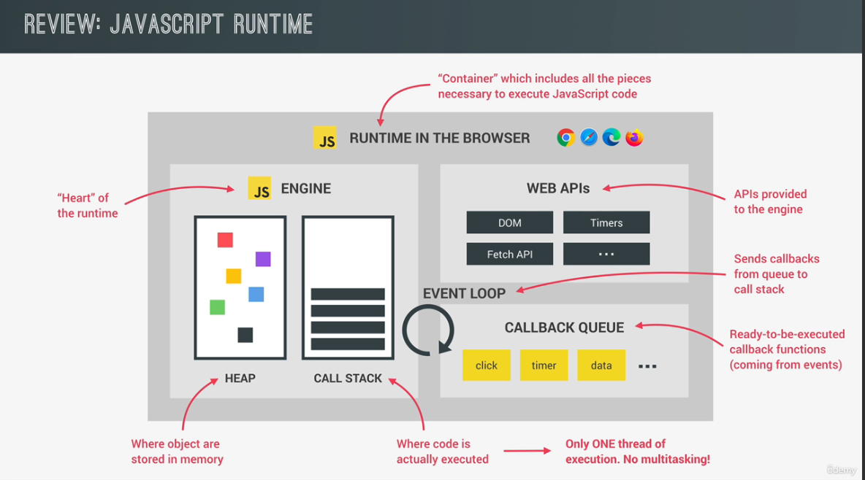

But now how does this non-blocking concurrency actually work? And why is the event loop so important?

Let's start by selecting this image element. And then in the next line we set the source attribute of that image to dog.jpg.

And as we learned before this will now start to load this image asynchronously in the background.

But this time we can actually understand what that mysterious background actually is.

So, as you already know everything related to the DOM is not really part of JavaScript, but of the web APIs.

And so it's in a web APIs environment where the asynchronous tasks related to the DOM will run.

And in fact,the same is true for timers AJAX calls and really all other asynchronous tasks.

So, again, these asynchronous tasks will all run in the web API environment of the browser.

Now, if the image would be loading in a synchronous way it would be doing so right in the call stack blocking the execution of the rest of the code.

But, as we already learned, that would be terrible.And that's why loading images in JavaScript is asynchronous.

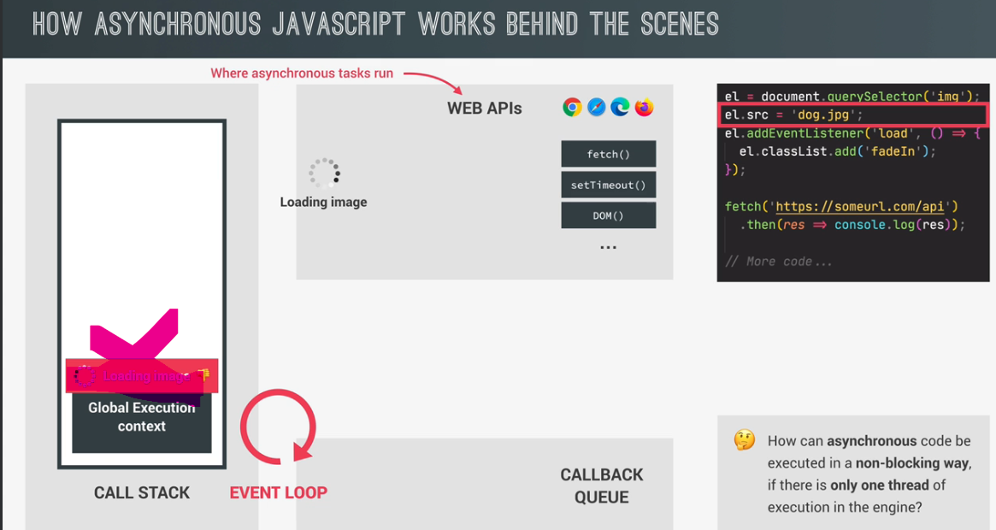

So it does not happen in the call stack.So, not in the main thread of execution,but really in the web APIs environment as I mentioned before.

Now, if we want to do something after the image has finished loading,then we need to listen to the load event.

And so that's exactly what we do in the next line of code.So, here we attach an event listener to the load event of that image and pass an a callback function as always.

In practice, this means to register this callback in the web APIs environment, exactly where the image is loading.

And to callback will stay there until the load event is emitted. So, we're handling asynchronous behavior here with a callback just as we learned before, but anyway, let's go back to the code.

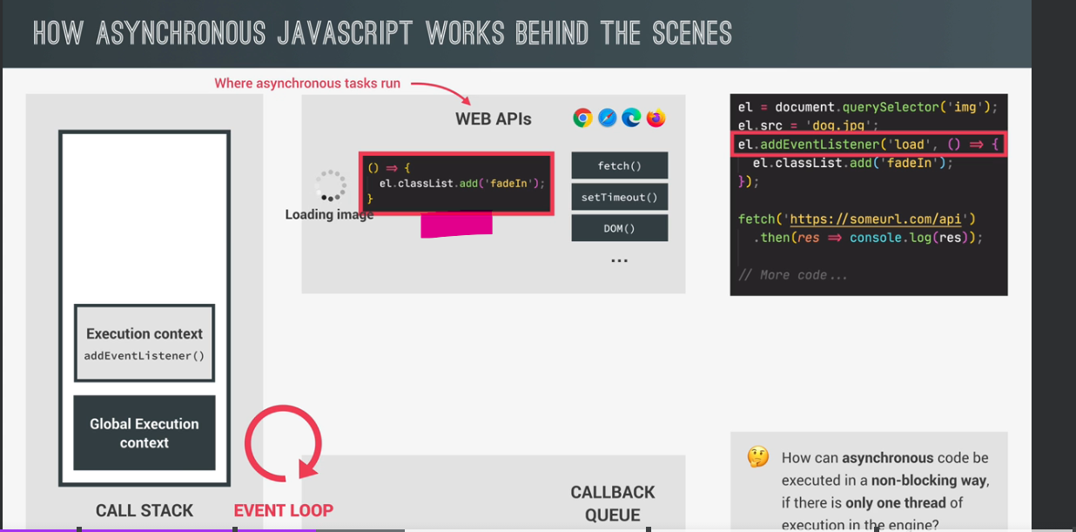

In the next line, we make an AJAX call using the fetch API.And as always the asynchronous fetch operation will happen in the web APIs environment.

And again, that's because otherwise we would be blocking the call stack and create a huge lag in our application.

Finally, we use the then method on the promise returned by the fetch function.

And this will also register a callback in the web API environment so that we can react to the future resolved value of the promise.

So this callback is associated with a promise that is fetching the data from the API.

So, with this, we have now executed all the top level of code. So, all the code that is not inside any callback function in asynchronous way.

We also have the image loading in the background and some data being fetched from an API.

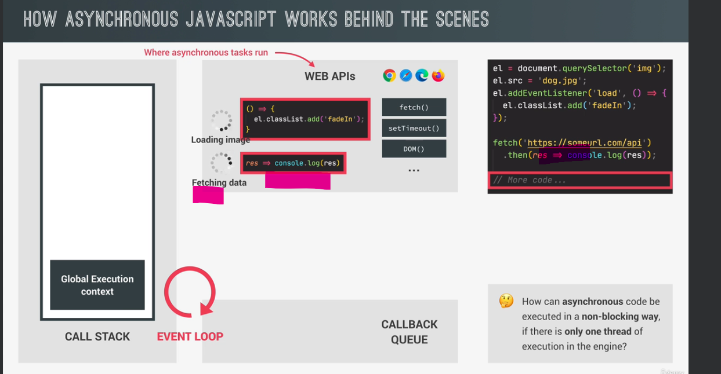

And so now it's time for this to get really interesting.

Let's say the image has finished loading and therefore the load event is emitted on that image.

What happens next,is that the callback for this event is put into callback queue.

And the callback queue is basically an ordered list of all the callback functions that are in line to be executed.

And you can think of this callback queue,as a to do list that you would write for yourself with all the tasks that you have to complete.

So, the callback queue is also a to do list of a kind, but with tasks that the call stack will eventually have to complete. Now, in this example, there are no other callbacks in the queue yet, but there could be of course. So, if there were already other callbacks waiting in line, then this new callback would of course go straight to the end of the queue.

And there it would sit patiently for its turn to finally run.And this actually has big implications.

So, imagine that you set a timer for five seconds.And so after five seconds that timer's callback will be put on the callback queue, right.

And let's say there were already other callbacks awaiting.And let's also say that it took one second to run all of those callbacks.

Then, in that case, your timers callback would only run after six seconds and not after five.

So, these six seconds are the five seconds that passed for the timer, plus the one second that it took to run all the other callbacks that were already waiting

in line in front of your timer.

So, what this means is that the timers duration that you define is not a guarantee.The only guarantee is that the timers callback will not run before five seconds, but it might very well run after five seconds have passed.

So, it all depends on the state of the callback queue. And also another queue that we're gonna learn about

in a second.Now, another thing that's important to mention here is that the callback queue also contains callbacks coming

from DOM events like clicks or key presses or whatever.Now, we learned before that DOM events are not really asynchronous behavior, but they still use the callback queue to run their attached callbacks.

So, if a click happens on a button with addEventListener then what will happen is just like what I illustrated here with the asynchronous load event.

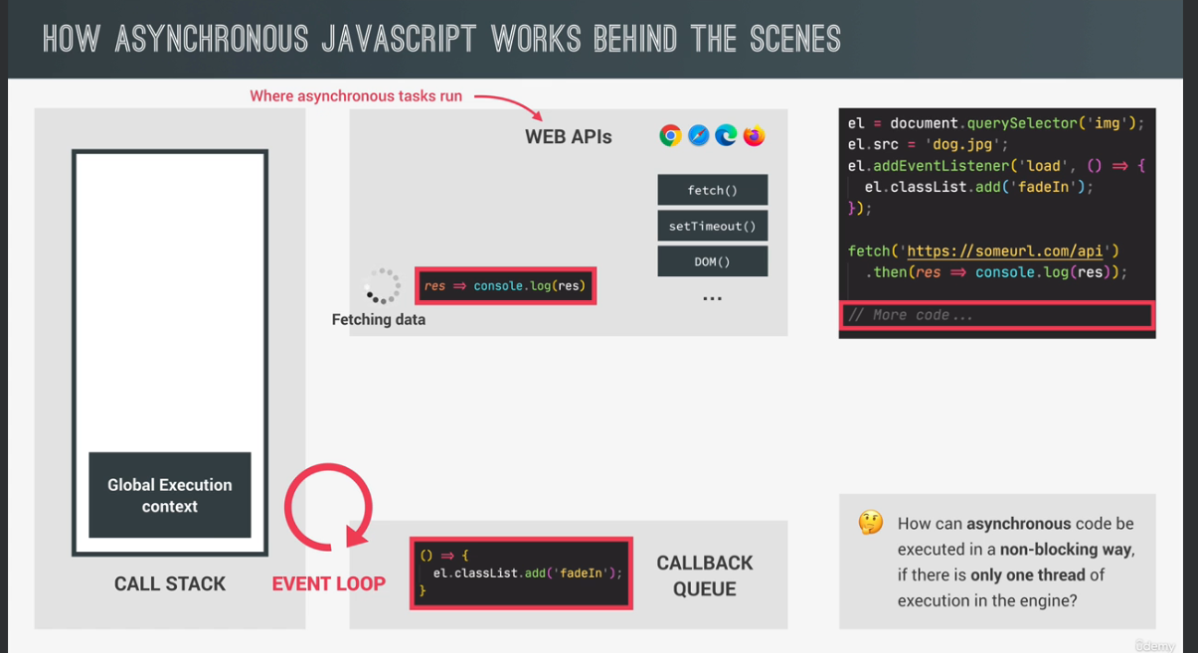

But anyway now it's time to finally learn about the **event loop**.

So, here is what the event loop does. It looks into the call stack and determines whether it's empty or not.

Except of course for the global context, then if the stack is indeed empty which means that there's currently no code being executed

then it will take the first callback from the callback queue and put it on the call stack two will be executed.

And this is called an **event loop tick**.So each time the event loop takes a callback from the callback queue.

We say that there was an event loop tick. So, as we can see here the event loop has the extremely important task of doing coordination between the call stack and to callbacks in the callback queue.So, the event loop is basically who decides exactly when each callback is executed.

We can also say that the event loop does the orchestration of this entire JavaScript runtime. Another thing that becomes clear from this whole explanation is that the JavaScript language itself has actually no sense of time. That’s because everything that is asynchronous does not happen in the engine. It's the runtime who manages all the asynchronous behaviour.

And it's the event loop who decides which code will be executed next. But the engine itself simply executes whatever code it has given.

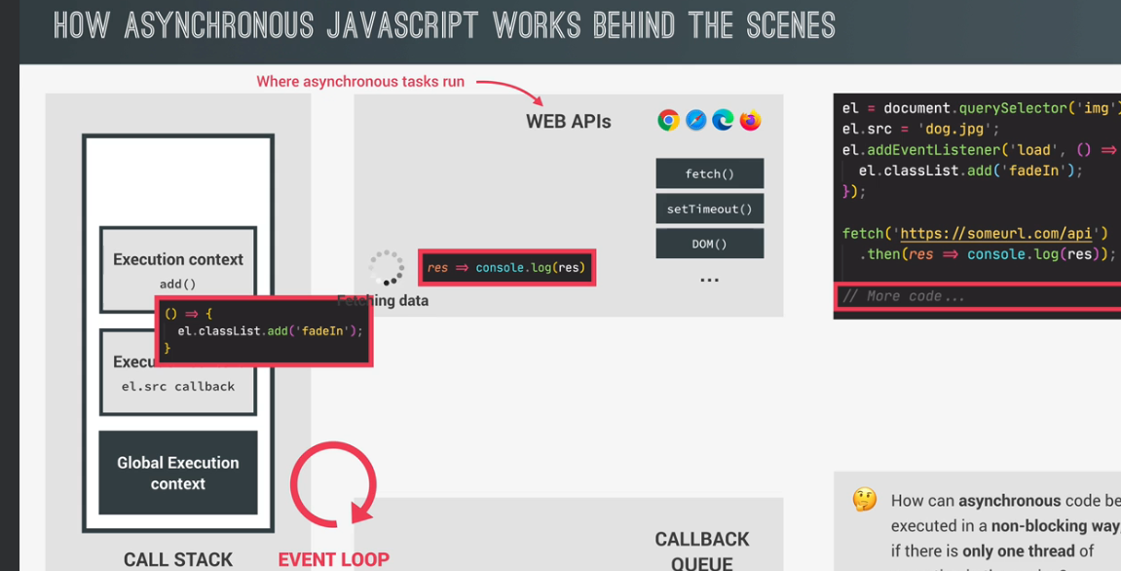

**In a nutshell,**

Okay, so, this is of course, a lot to take in. So let's try to recap what's happened here.

So, the image started loading asynchronously in the web APIs environment

and not in the call stack, right. We then used addEventListener to attach

a callback function to the image load event. And this callback is basically or asynchronous code it's code that we deferred into the future

because we only want to execute it once the image has loaded.

And in the meantime, the rest of the code kept running. Now addEventListener did not put the callback directly

in the callback queue.

It simply registered the callback, which then kept waiting

in the web APIs environment until the load event

was fired off.

Only then the environment put the call back into queue.

Then while in the queue the callback kept waiting

for the event loop to pick it up

and put it on the call stack.

And this happened as soon as the callback was first in line

and the call stack was empty.

And, that's it actually.

So, all this happened so that the image did not have to load

in the call stack, but in the background

in a non-blocking way.

So, in a nutshell, the web APIs environment,

the callback queue

and the event loop, all together, make it possible

that asynchronous code can be executed in a non blocking way

even with only one thread of execution in the engine.

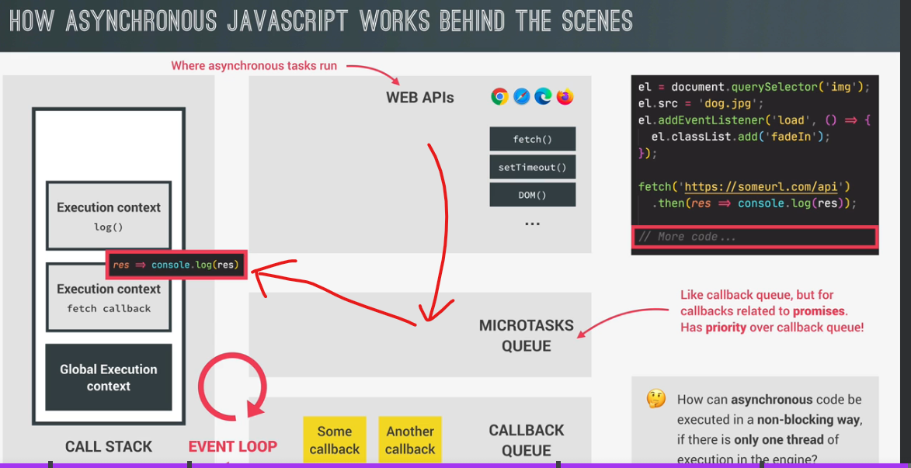

but we're not done yet.

Because we still have to fetch function

getting data from the AJAX call in the background.

And this is basically happening with a promise.

Remember, now with promises things work in a slightly

different way which is why I included this promise example

as well.

So, let's say that the data has now finally arrived.

And so the fetch is done.

Now, callbacks related to promises

like this one that we registered with the

promises then method.

Do actually not go into the callback queue.

So, again this callback did we still have here,

which is coming from a promise will not be moved into the

callback queue.

Instead, callbacks of promises have a special queue

for themselves, which is the so called microtasks queue.

Now, what is special about the microtasks queue is

that it basically has priority over the callback queue.

So, at the end of an event loop tick,

so after a callback has been taken

from the callback queue, the event loop will check

if there are any callbacks in the microtasks queue.

And if there are, it will run all of them

before it will run any more callbacks

from the regular callback queue.

And, by the way, we call these callbacks

from promises microtasks.

And therefore the name microtasks queue.

And there are actually other microtasks

but that's not relevant here.

So going back to our example,

currently, we actually do have a microtask sitting

in a microtasks queue, the call stack is also empty.

And therefore the event loop will now take this callback

and put it in the call stack just like it does with

callbacks from the callback queue.

And it doesn't matter if the callback queue is empty or not.

So, this would have worked the exact same way

even if there were some callbacks in the callback queue.

And again, that's because microtasks always have priority.

In practice, this means that microtasks can basically

cut in line before all other regular callbacks.

Now, if one microtask adds a new microtask

then that new microtask is also executed

before any callbacks from the callback queue.

And this means that the microtasks queue

can essentially starve the callback queue.

Because if we keep adding more and more microtasks,

then callbacks in the callback queue can never execute.

Event loop in practice:

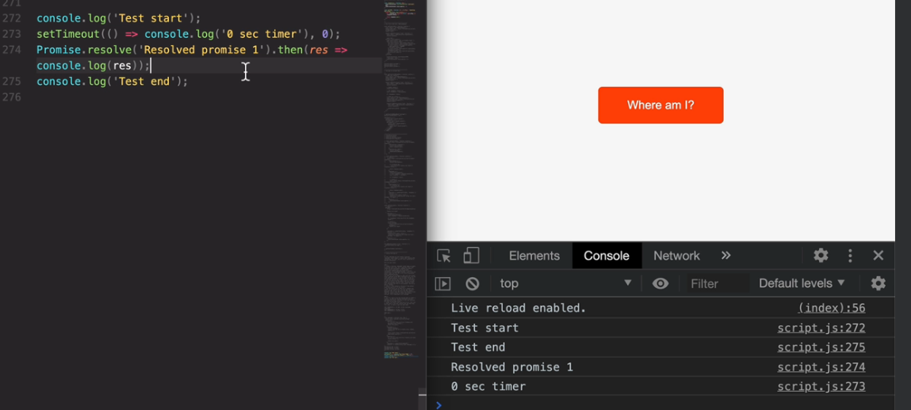

Let me now quickly, show you some of the stuff, that we just learned and practice. And so let's not build an extremely simple example. So I will start by simply logging test, start to the console. Then, afterwards I will create a set time out, with something that will just also lock something to the console only. So zero second timer. And so that's because we will fire this timer after exactly zero seconds. Okay. So basically this is a timer, which should call this timer function exactly after zero seconds. So what that means is that after zero seconds, this callback will be put on the callback queue, right? Then next up, let's build a promise that resolves immediately. So this is something that we will learn in the next video actually. And so for now, just follow what I'm writing here. So promise that resolve, basically allows us to build a promise, so to create a promise that is immediately resolved. So one that immediately has a success value. And so that fulfilled, success value, is gonna be this one we passed in here. So resolved, promise, one, and then we can handle that resolved promise. And so that, our response we can then simply log it to the console. So, just like in any other promise, we can handle it with a den method. And this callback function here, will get called with the resolved value, as an argument. And so in this case, the result value of that promise, is this one here that we just specified. And now just to finish, let's just log another string test. And, and so for now, that's actually it. So in what order do you think that these four messages, that we have here, will be logged to the console? And I want you to really think about this and maybe even pause the video, and write it down. Well, let's think about this together before we actually check out the result. So the first two messages that are gonna be printed should be pretty obvious, that's because we already know that any top level of coat. So coat outside of any callback, will run first. And so of course, the first two logs will come from these two synchronous, console dot log Sierra. But now between the timer, and the resolved promise here, it might be a little bit trickier. So both the timer and a promise, will finish at the exact same time. So both right after zero seconds. So the timer, because we told it to finish after zero seconds and a promise because we told it to immediately become resolved. Right? And so therefore, they will both finish at the exact same time. So which one do you think will be handled first or in other words, which of these two callbacks here will be executed first? Well, the timer appears first in the coat and so it kind of finished first. And so it's callback, will be put on the callback queue first, but does that mean that this call back here will be executed first? Well, actually, no, it doesn't. And that's because of the micro-tasks queue, remember? So the callback of the resolved promise here, so this one will be put on the micro-tasks queue and this micro-tasks queue, as you learned in the last video has priority over the callback queue. And so after this whole code runs, we will have one callback in a callback queue and one in a micro-tasks queue. And therefore the one from the micro tests queue should be executed first. And so therefore the callback from the micro-tasks queue should be executed first. And so that's this one here and there for the first message to appear of these two, should be resolved Promise one. All right. So the order in which they should appear is this tenders, tenders and finally the timer. And so that's now finally confirmed as, so I'm saving it and indeed did as exactly as expected. And so that's a relief actually. So what I told you in the last lecture is actually true. Now we proved it with coat. Now, remember that the implication of the fact that micro-tasks have priority over regular callbacks, is that if one of the micro-tasks takes a long time to run, then the timer will actually be delayed and not run after the zero seconds that we specified here, right? So instead it will run a little bit later just after the micro-task is actually done with its work.

Building a promise:

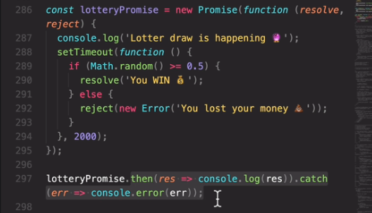

This code below replaces the commented code and its callback hell

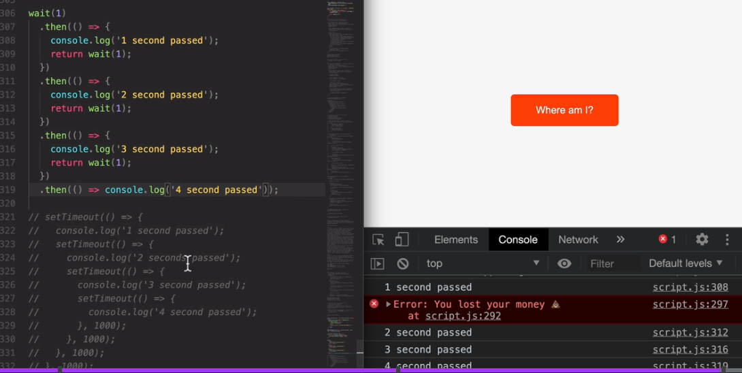

Consuming promises with Async/Await:

* since ES 2017, there is now an even better and easier way to consume premises, which is called a sync await. So let me show you how it works. So we start by creating a special kind of function, which is an a sync function.
* We can make a function async by simply putting async before it, that’s a function that runs in background asynchronously

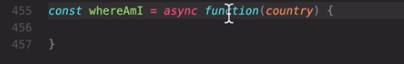

* Inside async function we can have one or more await functions, next to await we need a promise function.

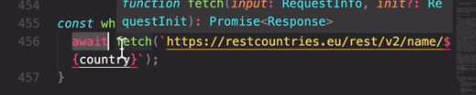

* So basically await will stop the code execution at this point of the function until the premise is fulfilled. And so until the data has been fetched in this case, but now after that explanation, you might think isn't stopping the code, blocking the execution? Well, that's a really good question, but the answer is actually no, in this case, because stopping execution in an a sync function, which is what we have here is actually not a problem because this function is running asynchronously in the background. And so therefore it is not blocking the main threat of execution. So it's not blocking the call stack. And in fact, that's, what's so special about a single wait. So it's the fact that it makes our code look like regular synchronous code while behind the scenes. Everything is in fact asynchronous. All right. But anyway, as soon as this premise here is resolved, then the value of this whole await expression that we have here is going to be the resolved value of the premise. And so we can simply store that into a variable. So let's call it res for response. And then here we can take a look at that response.

To prove that, you can see below that FIRST is executed first and then the function.

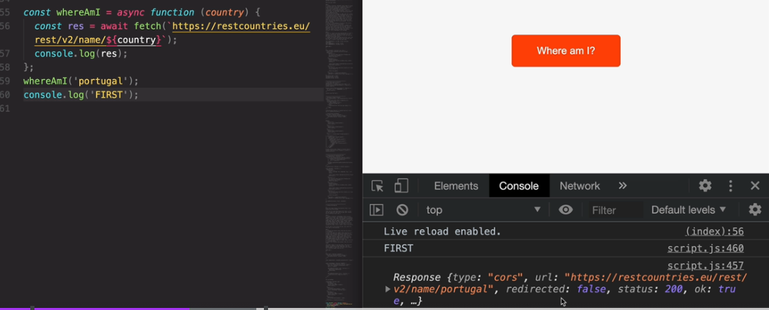

* The above scenario was not possible before and has to mess with callback functions and also by consuming promises with then method.

But now with async await, this is completely gone.

* Await is just syntactic sugar over the then method in promise, we just use a different method of consuming the promise.

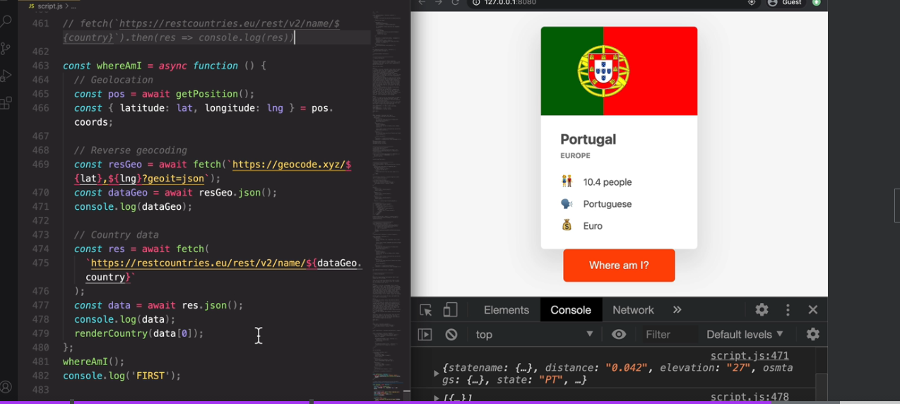

Error handling with try catch:

* we're gonna learn how error handling works with async/await. So with a sinc/await, we can't use the catch method that we use before, because we can really attach it anywhere, right. So instead, we use something called a try catch statement. And the try catch statement is actually used in regular JavaScript as well. So it's been in the language probably since the beginning. So try catch has nothing to do with async/await. But we can still use it to catch errors in async functions.

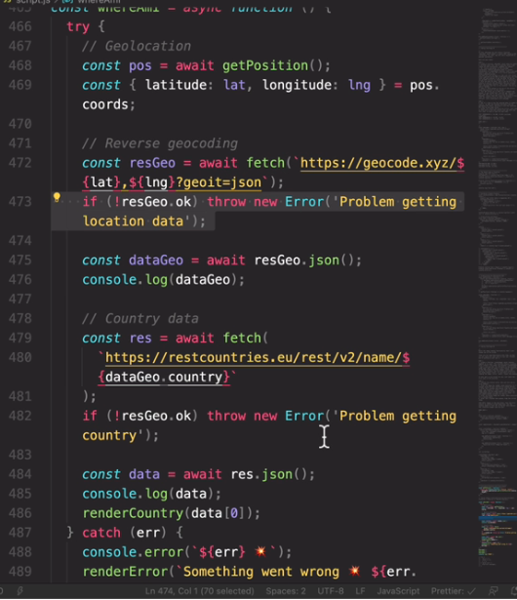

Returning value from Async functions:

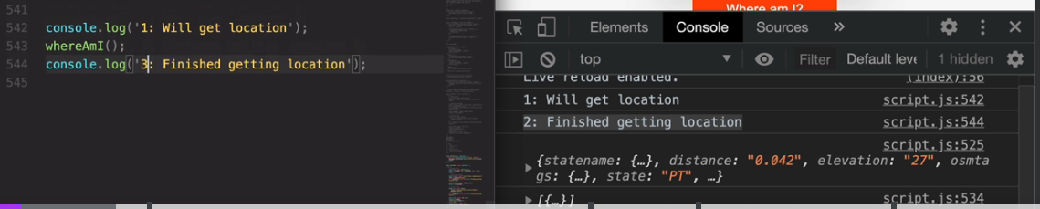

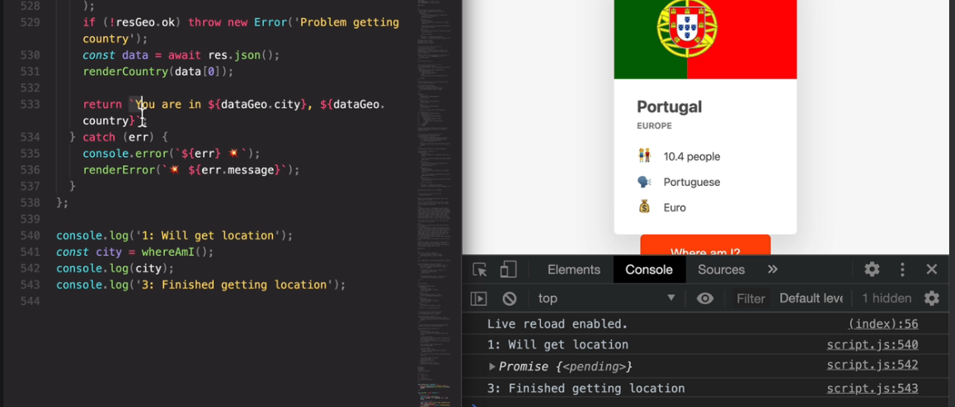

* how to get the response when there is return value from async function

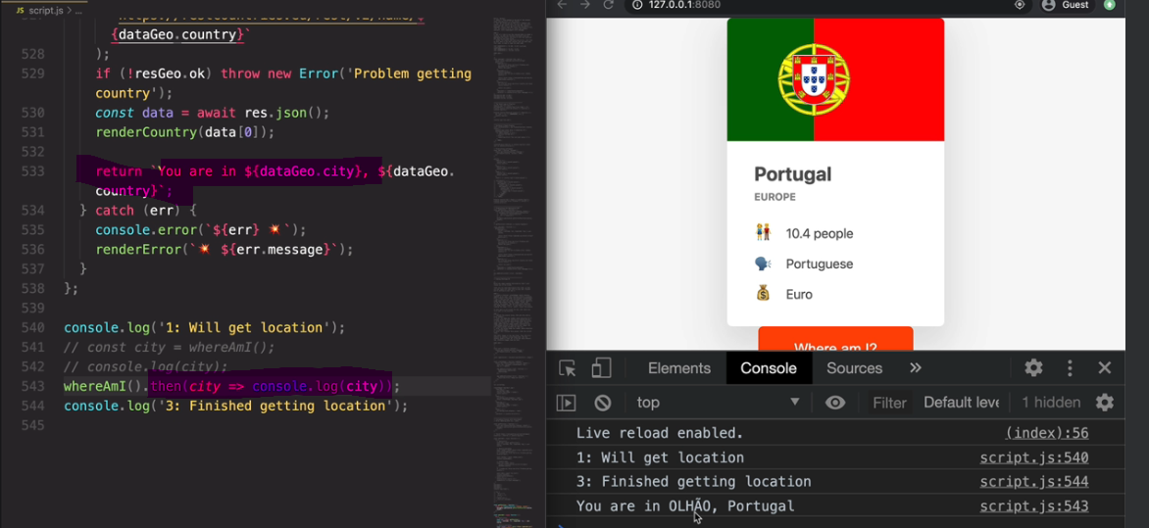

* Catching if there is any error

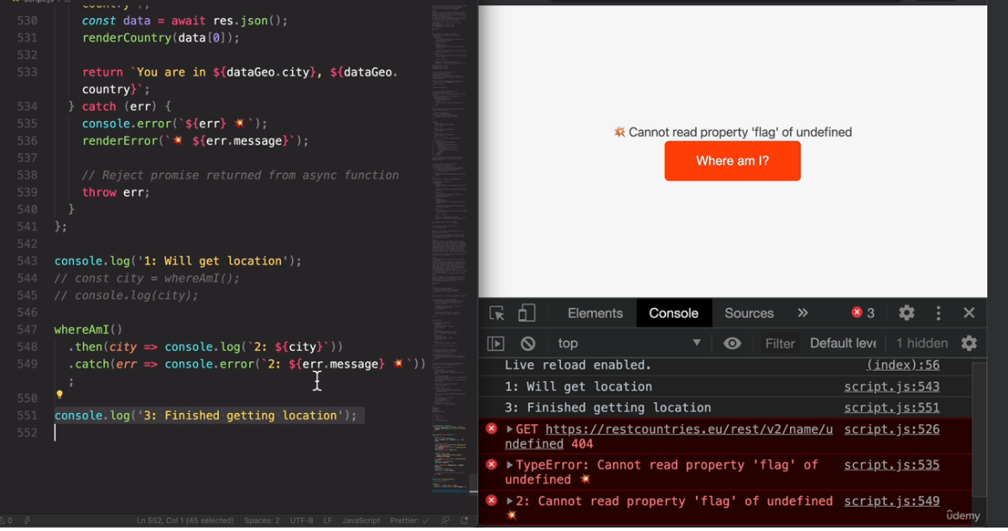

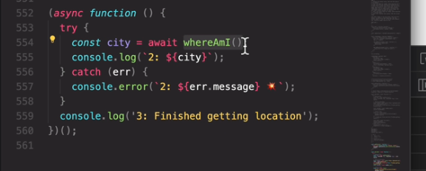

Running promises in parallel:

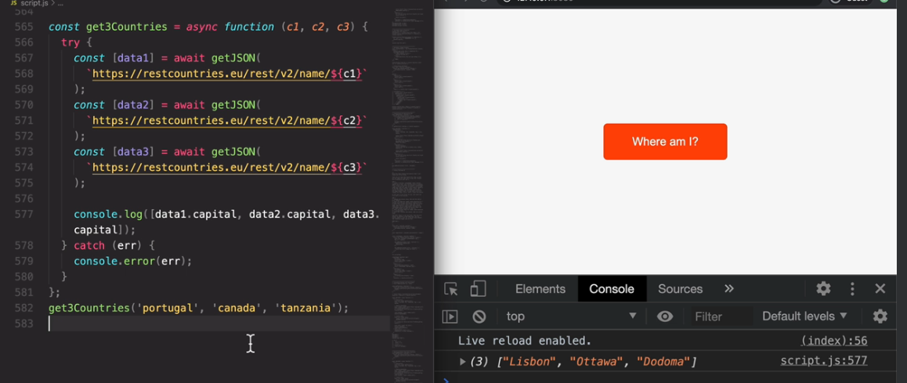

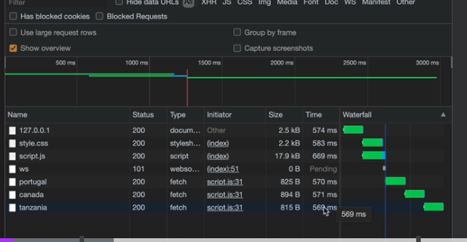

* What we did here is , the calls are happened one after the other, when they are independent why it has to happen like that in synchronous way
* But note that in below case, if one of the promise fails , all the calls fails

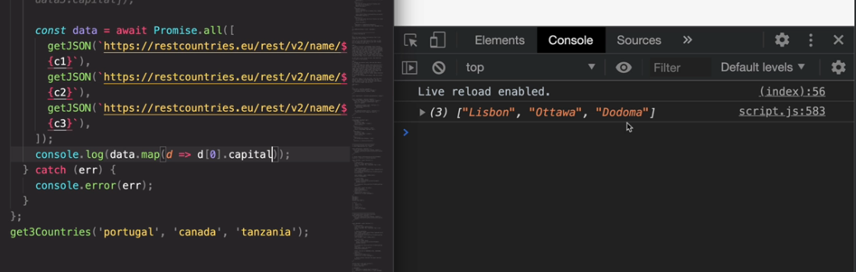

Other promise Combinators: race, allSettled and any

* Race: returns the value of one of the api calls that retuns promise fast
* When you execute again, the output might be different which is from any other api

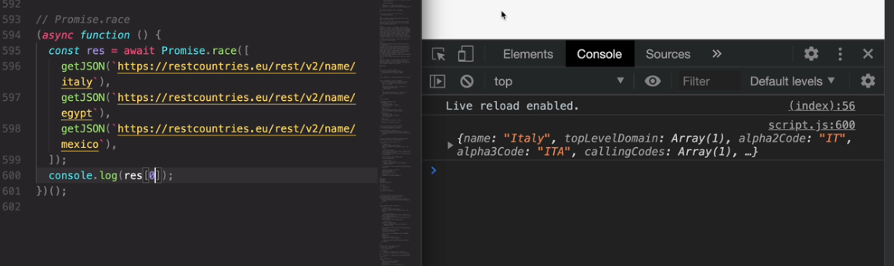

* Promise by time: Here 0.1 second is not enough to execute this api, so it gives timeout .

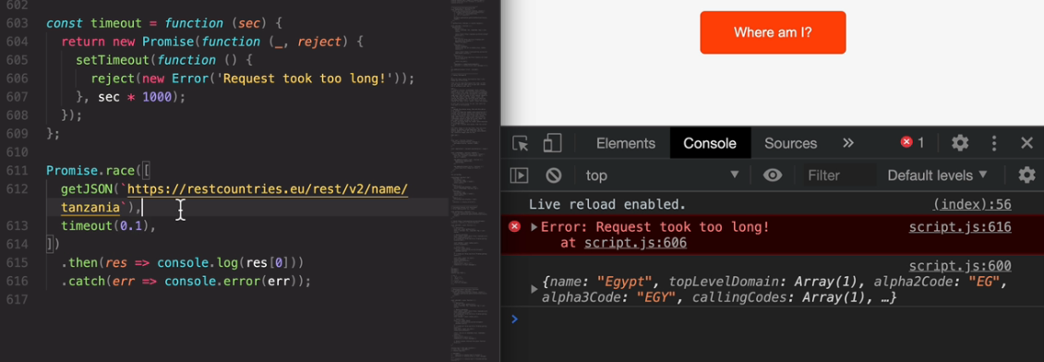

* Promiseallsettled returns all the promises regardless of success or fail

Here as we can see we got all three results

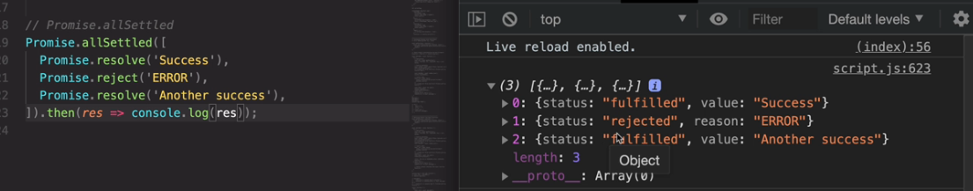

* Promiseall is opposite of PromiseallSettled, it will short circuit if there is even one error

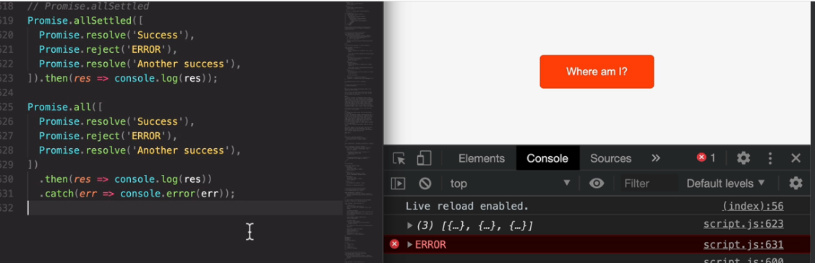

* Promise.any from ES2021, it is same as promsies.race but it simply ignores the rejected promises.

Latest browser only supports this

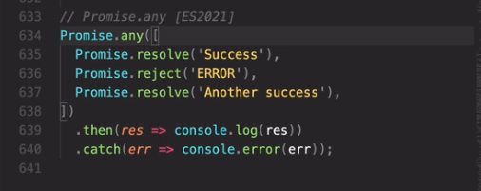

1. **Optional Chaining**

Lets start with a simple example with primitives.

1. **Optional Chaining**

Lets start with a simple example with primitives.

1. **Optional Chaining**

Lets start with a simple example with primitives.

1. **Optional Chaining**

Lets start with a simple example with primitives.

1. **Optional Chaining**

Lets start with a simple example with primitives.

1. **Optional Chaining**

Lets start with a simple example with primitives.

1. **Primitives vs objects**

Lets start with a simple example with primitives.